In Partial Fulfillment of the Requirements
for the Course
Software Engineering 1

KilosUnlad:
Smart 4Ps Welfare Auditing and
Fraud Detection System
S.Y 2026-2027

Submitted by:
Charles John R. Cabatian
Kit Dustin P. Martinez
Markie Angelo S. Mojica
Ma. Mae S. Santos
Renz Jerik C. Viloria

Date
October 17, 2026
Submitted To
Mr. Rogel M. Labanan
Group Information
Project Title: KilosUnlad: Smart 4Ps Welfare Auditing and Fraud Detection System
Group Name: KilosUnlad
Section: COM - 241
Project Members:
No. | Member Name | Assigned Role
1 | Viloria, Renz Jerik C. | Project Manager / Data Engineering Lead
2 | Cabatian, Charles John R. | Machine Learning Lead
3 | Mojica, Markie Angelo S. | Frontend Development
4 | Martinez, Kit Dustin P. | Database Lead
5 | Santos, Ma. Mae S. | Backend Infrastructure Lead
Table of Contents
1. Project Overview 4
2. Problem Statement 5
3. Project Objectives 6
4. Scope and Limitations 7
5. Requirements 9
6. System Modeling and Design 13
7. System Architecture 19
8. Database Design 21
9. User Interface Design 23
10. System Implementation 31
11. Transaction Processing 33
12. Software Testing 38
13. Challenges and Solutions 43
14. Conclusion 44
15. References 45
16. Appendices 47

1. Project Overview
KilosUnlad is a web system we built for the Department of Social Welfare and Development (DSWD) to help check the households in the Pantawid Pamilyang Pilipino Program, or 4Ps. Its full name is "KilosUnlad: Smart 4Ps Welfare Auditing and Fraud Detection System." The name comes from Kilos-Unlad, the case management approach that the 4Ps uses to help families move from survival to self-sufficiency (DSWD, 2023).
The system looks for families that may no longer need the cash grant, for example a family that has bought a car, uses a lot more electricity than a poor household would, or now pays for a postpaid phone plan. A machine learning model and a few simple checks give each household a risk score from 0 to 100. If the score is 70 or higher, the household is flagged. The flag does not remove anyone. It only tells the regional office that a caseworker should visit the house.
The system has four kinds of users. The Regional Director looks at the flagged households, sends caseworkers to visit them, and decides what happens next. The Caseworker (also called a Municipal Link) visits the home and fills in a short form on a phone, even without internet, and takes a photo of the house. The COA Auditor can only read the records and checks that no one has secretly changed them. The Super Admin can declare a calamity in an area, which pauses all audit actions there.
In the end, KilosUnlad helps the 4Ps money reach the families who still need it. It does this in three ways: it narrows thousands of households down to a short list worth visiting, it makes field visits faster and harder to fake, and it keeps an audit log that shows right away if a record was changed. Most importantly, the system never removes a family by itself. A person always makes the final decision, and the family can always appeal.
The final version of the system is hosted online. The web app runs on Vercel, the API and the machine learning service run on Render, and the database runs on MongoDB Atlas. The live link is https://kilos-unlad-33qx7w3d9-yuidevs.vercel.app/. The whole system can also run on one computer using Docker.

2. Problem Statement
The 4Ps gives cash grants to poor families on the condition that their children stay in school and get health checkups. A family can stay in the program for up to seven years (Republic Act No. 11310, 2019). The program only works well if the money goes to the families who really need it. Right now, there are four problems that get in the way.
The first problem is graduation lag. Some families improve their lives while in the program. They buy a vehicle, open a small business, or start receiving money from a relative abroad. But the DSWD does not easily see these changes, so these families stay on the list for months or even years. Because the program budget is limited, every slot held by a family that has already moved on is a slot that a poorer family on the waiting list cannot get.
The second problem is that checking families is slow. The only way to really confirm a family's situation is a home visit, and these visits are mostly done on paper. With millions of households enrolled and only a limited number of caseworkers, records become outdated before anyone can visit.
The third problem is that records can be changed without anyone noticing. If a record is edited, there is no simple way to prove who changed it or what it looked like before. This opens the door to "palakasan," where someone protects a friend from being removed from the program or pushes out someone they do not like.
The fourth problem is the "Sangla-ATM" practice. Some lenders take a family's LandBank cash card as collateral for a loan and withdraw the grant themselves on payout day. When this happens, the money never reaches the children it was meant for.
Our problem, then, is this: how can the DSWD find the households that may have outgrown the 4Ps, confirm it fairly with a real field visit, and keep a record that cannot be quietly changed, without removing any family unfairly?

3. Project Objectives

3.1 General Objective
To build a web-based audit system for the DSWD that helps find 4Ps households that may no longer qualify, sends caseworkers to confirm it in the field, and keeps a tamper-evident record of every decision, while always leaving the final decision to a person.

3.2 Specific Objectives
- To build a scoring engine that uses a machine learning model (LightGBM) to predict each household's SWDI level and adds simple record checks (electricity, water, phone plan and vehicle) to give a risk score from 0 to 100, with the reasons shown for every flag.
- To build a mobile-friendly web app (PWA) that lets caseworkers download their visits, fill in a 5-step form with a geotagged photo, and save the report on the phone when there is no internet, then send it automatically when the connection comes back.
- To keep an audit log where every change is saved together with a SHA-256 hash of the change before it, so that any edit to an old record can be detected right away by the COA auditor.
- To follow due process by giving every family a 15-day appeal window after a notice, keeping their grants during that time, and recording the outcome of every appeal hearing.
- To detect Sangla-ATM patterns by looking at ATM log windows for many cards swiped quickly at one machine late at night.
- To test the system fully, from unit tests to end-to-end tests, and to host it online so that our adviser and panel can use it.

4. Scope and Limitations

4.1 Scope
KilosUnlad covers the full audit process for 4Ps households in one pilot area, from the first flag up to the final decision. It includes the following:
- A web app for the office and the field, built with React, that works on phones, tablets and laptops and can be installed like an app (PWA).
- Four user roles (Regional Director, Caseworker, COA Auditor, Super Admin), each with its own screens and permissions. Users only see households inside their assigned area.
- Risk scoring with a LightGBM model trained on real survey data from the PSA 2015 Family Income and Expenditure Survey, plus checks on electricity, water, phone plan and vehicle records. Every flag shows its top three reasons using SHAP.
- Sending caseworkers to flagged homes. The director can only pick a caseworker who covers that household's barangay.
- Offline field visits with a 5-step form, a geotagged photo, and a SHA-256 fingerprint of the photo. The server checks that the photo was taken within 250 meters of the house.
- The full decision process: keeping a family on the program, issuing a notice, a 15-day appeal window, recording the hearing outcome, and graduation.
- A calamity freeze (based on Republic Act No. 10121) that stops dispatch and new flags in a declared area, and a 180-day period where a family that was kept on the program cannot be flagged again.
- Sangla-ATM detection on ATM log windows.
- A hash-chained audit log that the COA auditor can verify at any time.
- A pilot dataset of 20,000 synthetic households in Calamba, Laguna (barangays Palingon, Lecheria and Real), with a caseworker for every barangay.

4.2 Limitations
- The system does not remove families on its own and does not stop or change any cash payment. It only gives advice. Every final decision is made by an authorized person.
- The system does not connect to real government or bank databases (Meralco, water districts, LTO, telecom companies or LandBank). We used synthetic (made-up) records instead, because the Data Privacy Act of 2012 and the Bank Secrecy Law protect this kind of personal data (Republic Act No. 10173, 2012; Republic Act No. 1405, 1955).
- The system does not look at private bank accounts, e-wallets or anyone's browsing history.
- The households in the system are synthetic. Only the machine learning model was trained on real, anonymous survey data from the PSA (Philippine Statistics Authority [PSA], 2016).
- The pilot covers only one city: Calamba, Laguna. It is a school prototype, not a nationwide system.
- The model is right often, but not always. Its macro F1 score is 0.6244, which is below our target of 0.85. This is one more reason why a flag only schedules a visit.
- Offline reports still need internet at some point to be sent. GPS and the photo depend on the caseworker's phone.
- On the free hosting plan, the API sleeps after 15 minutes without visitors, and uploaded photos are lost when it restarts. The photo fingerprints and audit records stay in the database.
- The system does not handle ordering a second field visit for the same case, and the sign-in page does not lock an account after many wrong passwords yet.

5. Requirements

5.1 Target Users and Stakeholders
User/Stakeholder | Description
Regional Director | Main decision maker. Sees the dashboard and map, reviews flagged households, sends caseworkers, reads field reports, keeps a family on the program or issues a notice, and records appeal outcomes. Can only see households in their region.
Caseworker (Municipal Link) | Does the home visits. Sees only the visits assigned to them, fills in the 5-step form, takes a geotagged photo and sends the report, even after working offline.
COA Auditor | Read-only user from the Commission on Audit. Checks the audit log to make sure no record was secretly changed. Cannot dispatch or decide anything.
Super Admin | System administrator. Has the director's view plus the power to declare and lift a calamity freeze.
4Ps households (stakeholder) | The families being audited. They benefit from fair checks, a 15-day appeal window, and grants that continue while they appeal.
Waitlisted poor families (stakeholder) | Families waiting to enter the 4Ps. They benefit when slots held by families who have already moved on are freed up.
DSWD (stakeholder) | The agency that runs the 4Ps and would own the system.

5.2 Functional Requirements
ID | Requirement
FR-01 | The system shall let users sign in with a username and password and show only the screens allowed for their role.
FR-02 | The system shall show each user only the households inside their assigned municipality and barangays.
FR-03 | The system shall compute a 0 to 100 risk score for a household using the machine learning model and the electricity, water, phone plan and vehicle checks, and flag it when the score is 70 or higher.
FR-04 | The system shall show the top three reasons (SHAP) and the trigger badges for every flagged household.
FR-05 | The system shall list flagged households in a triage queue sorted by risk score, with search and filters.
FR-06 | The system shall let the director dispatch a flagged household to an active caseworker who covers its barangay, with instructions, a deadline and a priority.
FR-07 | The system shall let caseworkers download their assigned visits and keep them on the phone for offline use.
FR-08 | The system shall let caseworkers fill in a 5-step visit form (house, assets, cash card, photo, recommendation) and save it on the phone.
FR-09 | The system shall compute a SHA-256 fingerprint of each photo on the phone and attach the GPS location.
FR-10 | The system shall send saved reports automatically when the connection returns, without sending the same report twice.
FR-11 | The system shall reject a report if the photo fingerprint does not match or if the photo was taken more than 250 meters from the house.
FR-12 | The system shall let the director review a report with its photo and either keep the family on the program or issue a notice of ineligibility.
FR-13 | The system shall open a 15-day appeal window after a notice, let the director file an appeal, and record the hearing outcome (granted or denied).
FR-14 | The system shall graduate a household only after the appeal window has passed with no appeal, or after an appeal is denied.
FR-15 | The system shall let the Super Admin declare and lift a calamity freeze for a municipality, which stops dispatch and new flags there.
FR-16 | The system shall save every change in a hash-chained audit log and let the COA auditor verify any range of it.
FR-17 | The system shall detect possible Sangla-ATM patterns in ATM log windows.
FR-18 | The system shall show live dashboard numbers and a map of households, computed from the database.

5.3 Non-Functional Requirements
Category | Requirement
Security | Passwords are stored only as bcrypt hashes. Sign-in tokens expire after 15 minutes. Every request passes six guards: sign-in, role, area, input validation, business rules, and the audit seal. The app's database account can add audit records but cannot edit or delete them.
Usability | Screens use plain words (for example "Start this visit" and "What to check"). Each role sees only its own menu. Every screen works at phone (390 px), tablet (834 px) and desktop (1440 px) width with no sideways scrolling, and buttons are at least 44 px tall.
Reliability | A status change and its audit record are saved together in one database transaction, or not at all. Reports saved offline are never lost and never sent twice. If the machine learning service is slow or down, the API uses the published rules and records that it did.
Performance | The API waits at most 2.5 seconds for the model. Database queries use indexes (no full collection scans). The full 20,000-household dataset, with caseworkers, flags and audit records, can be rebuilt in about one minute.
Privacy and legal | Only synthetic household data is stored. No bank account, e-wallet or browsing data is collected (Republic Act No. 10173, 2012; Republic Act No. 1405, 1955).
Portability | The whole system starts on any computer with Docker using one command, and the same parts can be hosted on Vercel, Render and MongoDB Atlas.

5.4 Business Rules
- The system never removes a family by itself. Only a director can issue a notice, and only after a field report.
- A household is flagged only when its risk score is 70 or higher. The score adds 40 points for each SWDI level the model predicts above the enrolled level, 20 points for electricity above 200 kWh a month (the lifeline limit under Republic Act No. 11552, 2021), 15 points for water above 25 cubic meters a month, 25 points for a postpaid phone plan, and 30 points for a registered private four-wheel vehicle, up to a maximum of 100.
- A household can only move along fixed steps: Active → Flagged → Under investigation → Notice → Graduated, or back to Active when the family is kept on the program or wins an appeal. Any other move is refused.
- A caseworker can only be sent to households in the barangays assigned to them.
- A field report is accepted only if the photo fingerprint matches and the photo was taken within 250 meters of the household.
- After a notice, the family has 15 days to appeal, and grants continue during this time (Republic Act No. 11310, 2019). An appeal pauses graduation until the hearing outcome is recorded.
- A family that was kept on the program, or that won its appeal, cannot be flagged again for 180 days.
- During a declared calamity, no new flags or dispatches are allowed in that municipality (Republic Act No. 10121, 2010). Keeping a family on the program and granting an appeal are still allowed.
- Only the Super Admin can declare or lift a calamity. The COA auditor can read everything in scope but cannot change anything.
- Every change is saved in the audit log with a SHA-256 hash of the previous record.

5.5 Requirements Gathering
Methods used:
☐ Interview
☐ Observation
☐ Questionnaire
☒ Document Analysis
☒ Other: review of public datasets and existing government systems
We gathered our requirements mainly by reading and analyzing documents. We studied Republic Act No. 11310, the law that made the 4Ps permanent, to understand who qualifies, how long a family can stay, and what due process a family gets. We read the DSWD guidance note on the Kilos-Unlad strategy to understand how caseworkers work with families (DSWD, 2023). We also read the laws that limit what data we can use: the Data Privacy Act, the Bank Secrecy Law, and the Credit Information System Act (Republic Act No. 10173, 2012; Republic Act No. 1405, 1955; Republic Act No. 9510, 2008). Republic Act No. 11552 gave us the 200 kWh electricity limit, and Republic Act No. 10121 gave us the rules for calamity areas.
For the data side, we studied the PSA 2015 Family Income and Expenditure Survey, which reported that the average Filipino family earned about 22 thousand pesos a month in 2015 (PSA, 2016). We used this survey to choose the household features for our model. Finally, we listed the problems in the current manual process (Section 2) and turned each one into requirements. These requirements were reviewed with our adviser during our consultations and presentations.

6. System Modeling and Design
This section shows the UML diagrams of KilosUnlad. All diagrams were made with PlantUML from the actual code, so they match what the system really does. The source files are in the docs/diagrams/src folder of our repository.

6.1 Use Case Diagram
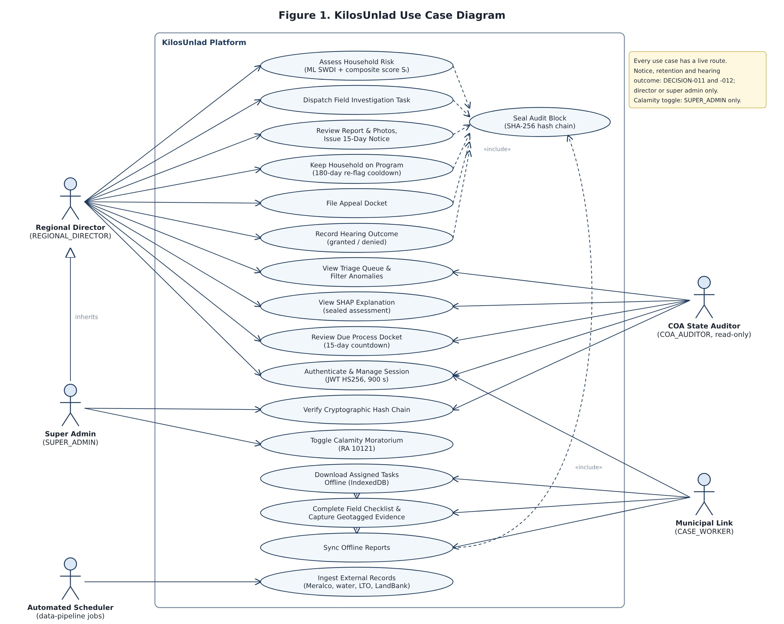
Figure 1. Use Case Diagram
Description: The use case diagram shows what each of the four users can do. The Regional Director views the dashboard, reviews the triage queue, dispatches caseworkers, reviews field reports, keeps a family on the program or issues a notice, files appeals and records hearing outcomes. The Caseworker views assigned visits, fills in the field form offline and sends the report. The COA Auditor views the audit overview and verifies the audit chain. The Super Admin does everything the director does and also declares or lifts a calamity freeze. Every use case that changes data also includes "seal an audit block," which shows that every change is recorded.

6.2 Activity Diagram
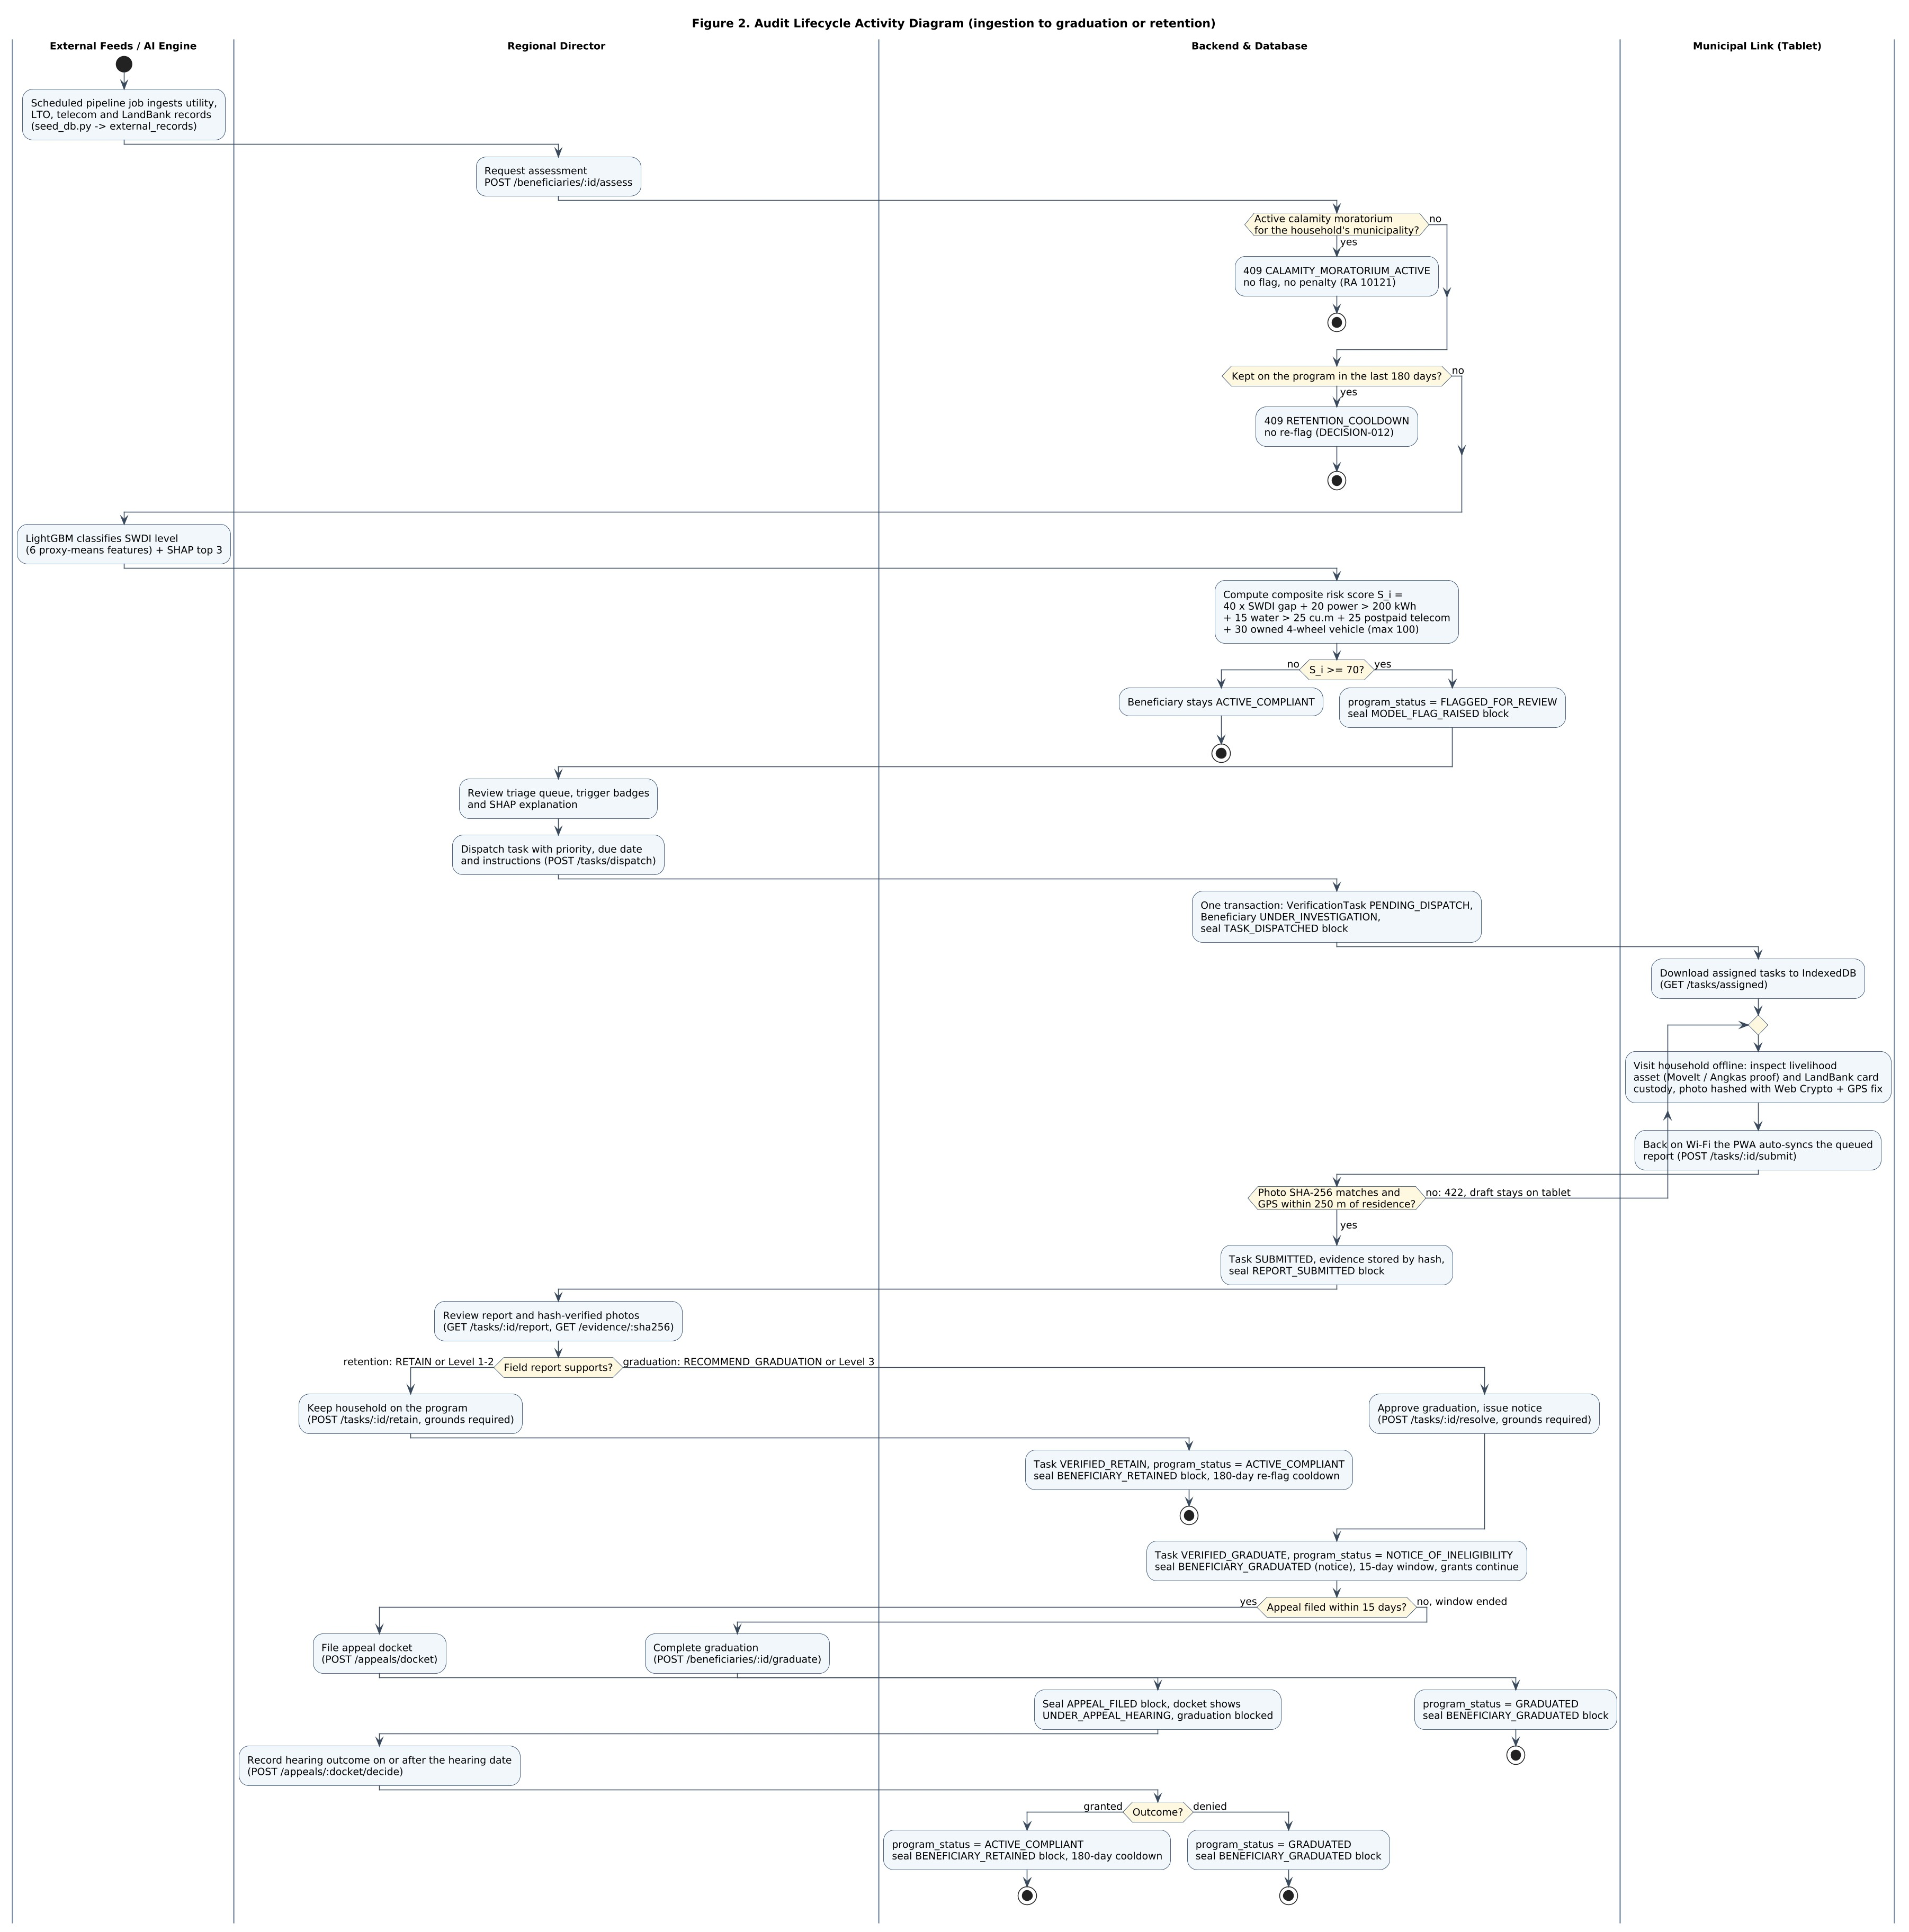
Figure 2. Activity Diagram
Description: The activity diagram shows the whole audit process from start to finish, split into lanes for the system, the director, the caseworker and the audit log. First, the system checks if there is a calamity freeze or a 180-day cooldown. If not, it scores the household, and if the score is 70 or higher, it raises a flag. The director then sends a caseworker. The caseworker visits, takes a photo and sends the report, which is accepted only if the photo fingerprint matches and the location is within 250 meters. The director then either keeps the family on the program or issues a notice. After a notice, the family has 15 days. With no appeal, the family graduates. With an appeal, the hearing outcome decides: granted means the family stays, denied means it graduates.

6.3 Class Diagram
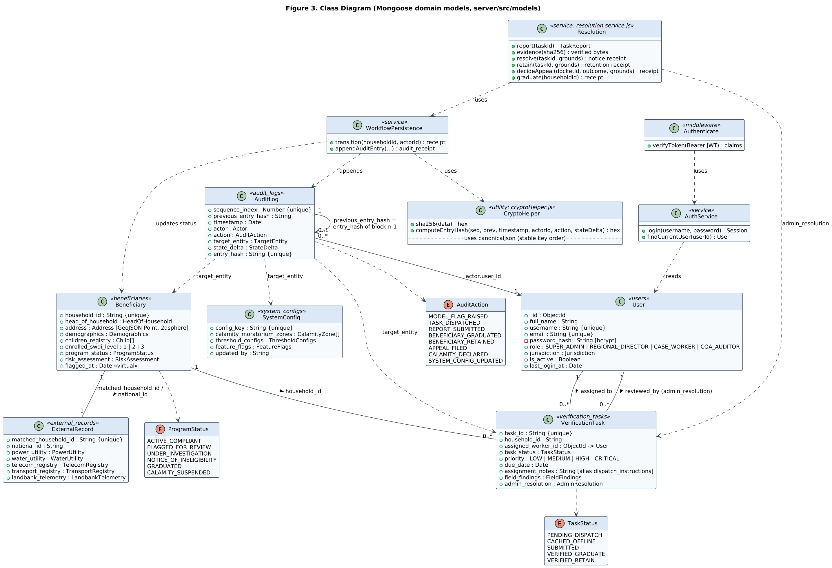
Figure 3. Class Diagram
Description: The class diagram shows the six data models of the system (User, Beneficiary, VerificationTask, AuditLog, ExternalRecord and SystemConfig) with their main fields and how they connect. For example, a VerificationTask belongs to one Beneficiary and is assigned to one User (the caseworker), and every AuditLog entry points to the record it changed. The diagram also shows the main services that do the work, such as the sign-in service, the workflow service that checks every status change, the resolution service for notices, retention and appeal outcomes, and the function that computes each audit hash.

6.4 Other UML Diagrams
We added three more diagrams to explain the parts of the system that are hard to show in the first three.
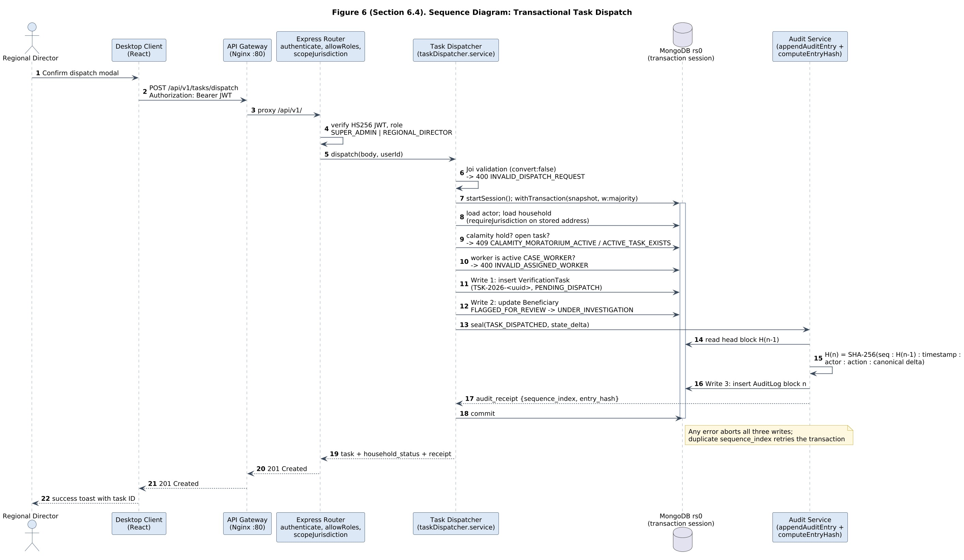
Figure 6. Sequence Diagram: Task Dispatch
Description: This sequence diagram shows what happens, step by step, when the director confirms a dispatch. The request goes through the gateway and the guards (sign-in, role and area). The task dispatcher then checks the input and, inside one database transaction, saves the new task, changes the household to Under Investigation, and writes the audit record. If anything fails, all three changes are undone together.
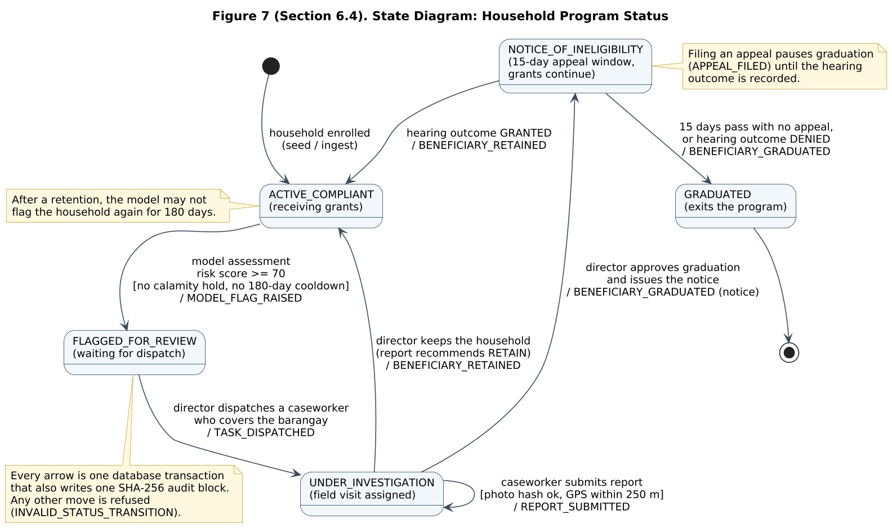
Figure 7. State Diagram: Household Program Status
Description: The state diagram shows the five statuses a household can have and the only moves allowed between them. A household starts as Active. A model flag moves it to Flagged, a dispatch moves it to Under Investigation, and the director's decision moves it either back to Active (kept on the program) or to Notice of Ineligibility. From the notice, it moves to Graduated after 15 days with no appeal or after a denied appeal, or back to Active if the appeal is granted. Each move also writes one audit record. Any other move is refused by the system.
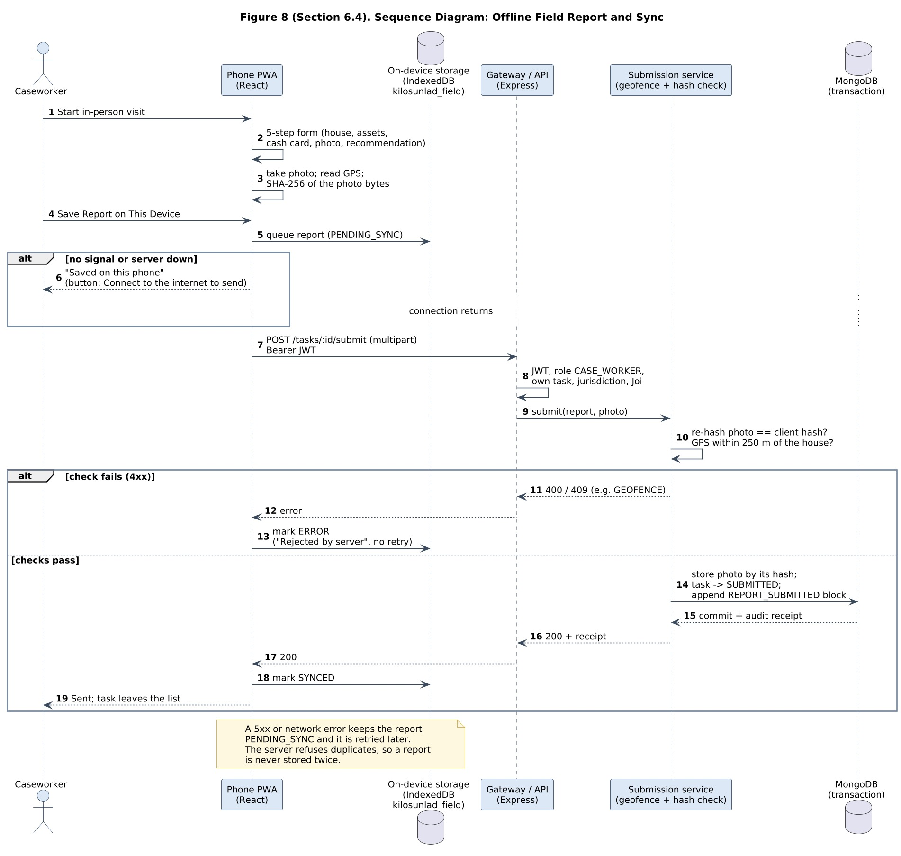
Figure 8. Sequence Diagram: Offline Field Report and Sync
Description: This sequence diagram shows how a field report is saved and sent. The caseworker fills in the form, takes a photo, and the phone computes the photo fingerprint and reads the GPS. The report is first saved on the phone. When there is a connection, the phone sends it to the API. The server checks the fingerprint and the location. If a check fails, the phone marks the report "Rejected by server" and does not keep retrying. If the checks pass, the report, the task update and the audit record are saved together, and the task leaves the caseworker's list.

7. System Architecture
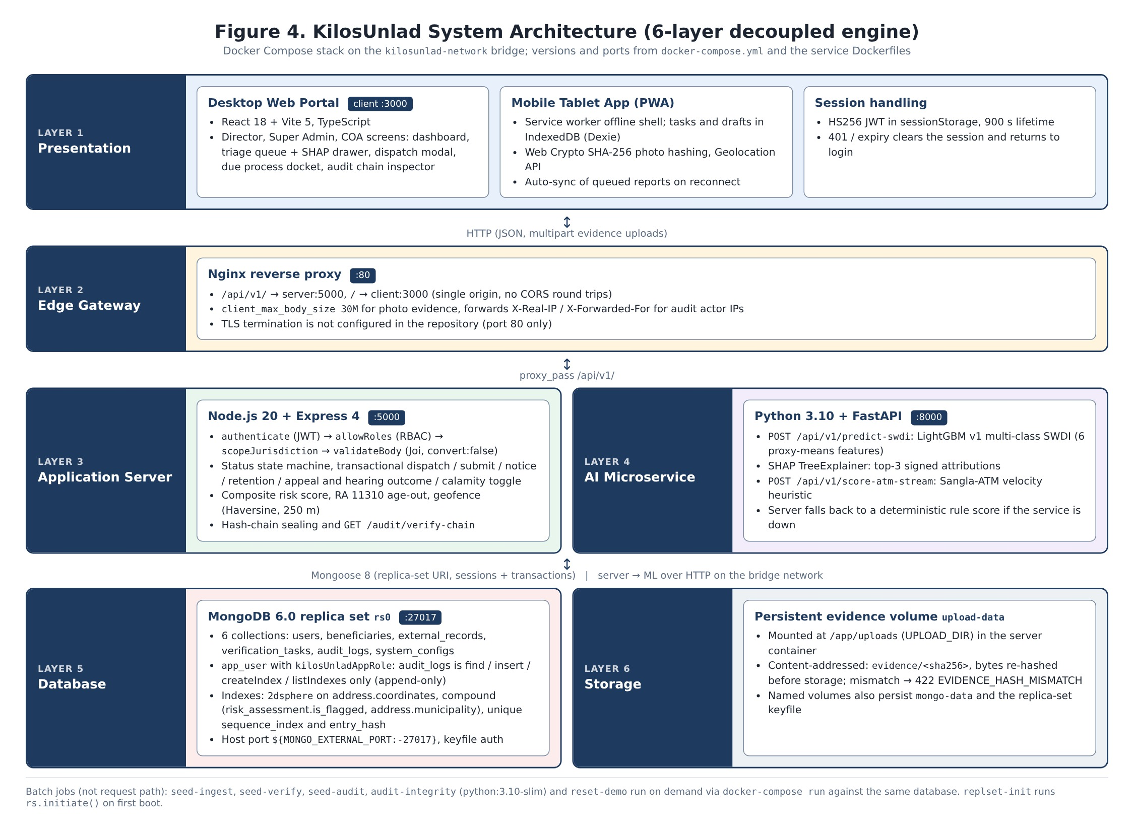
Figure 4. System Architecture
Description: KilosUnlad is split into separate parts that each do one job.
- Frontend (React PWA): the screens for the office and the field. It saves offline reports in the phone's storage (IndexedDB) and never talks to the model directly.
- Gateway (nginx): one address for the app and the API when running locally. On the hosted version, Vercel serves the app and Render serves the API.
- Backend (Node.js and Express): the "gatekeeper." It checks every request with the six guards, runs the workflow, and writes the audit records.
- Machine learning service (Python and FastAPI): predicts the SWDI level with the LightGBM model, explains it with SHAP, and runs the Sangla-ATM check. Only the backend calls it.
- Database (MongoDB): stores the six collections. It runs as a replica set so that we can use transactions.
- Evidence storage: field photos are stored by their SHA-256 fingerprint and checked again every time someone opens them.
We kept these parts separate so that each one can be changed without breaking the others. For example, the model can be retrained without touching the app, and the screens can be redesigned without touching the audit log. Figure 9 shows how the same parts are hosted online.
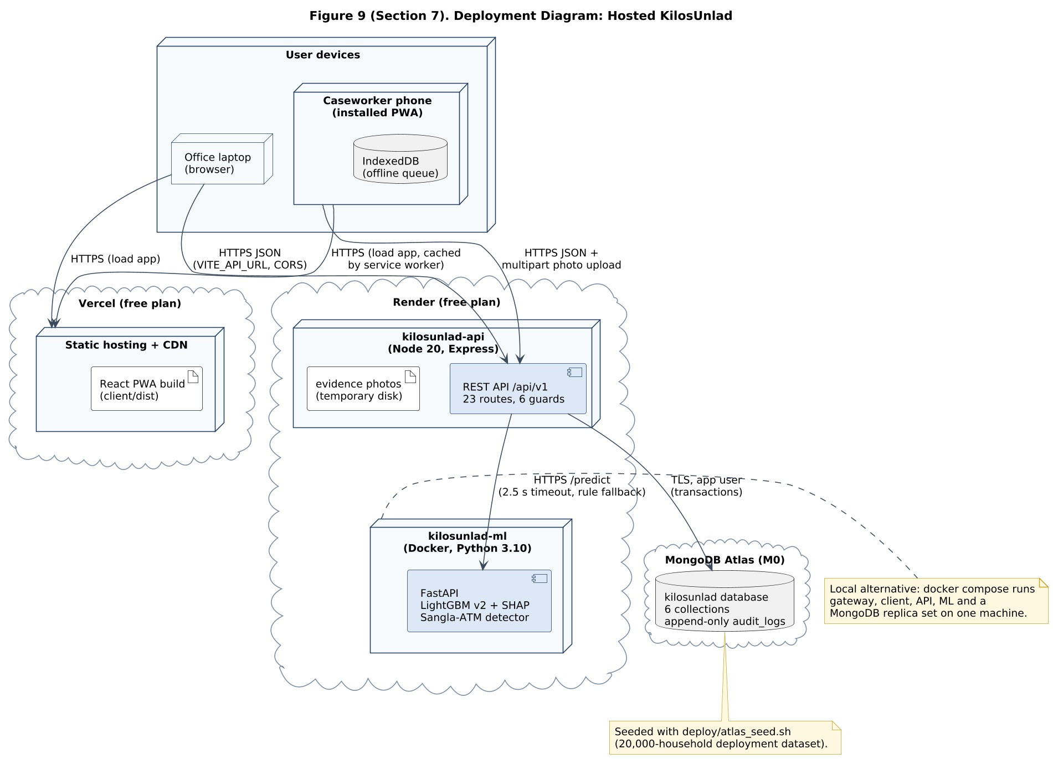
Figure 9. Deployment Diagram: Hosted KilosUnlad
Description: The deployment diagram shows where each part runs. Users open the app from Vercel on a laptop or phone. The app calls the API on Render over HTTPS. The API calls the machine learning service, which also runs on Render, and stores data in MongoDB Atlas. On a phone, offline reports wait in IndexedDB until they can be sent.

8. Database Design

8.1 Entity Relationship Diagram
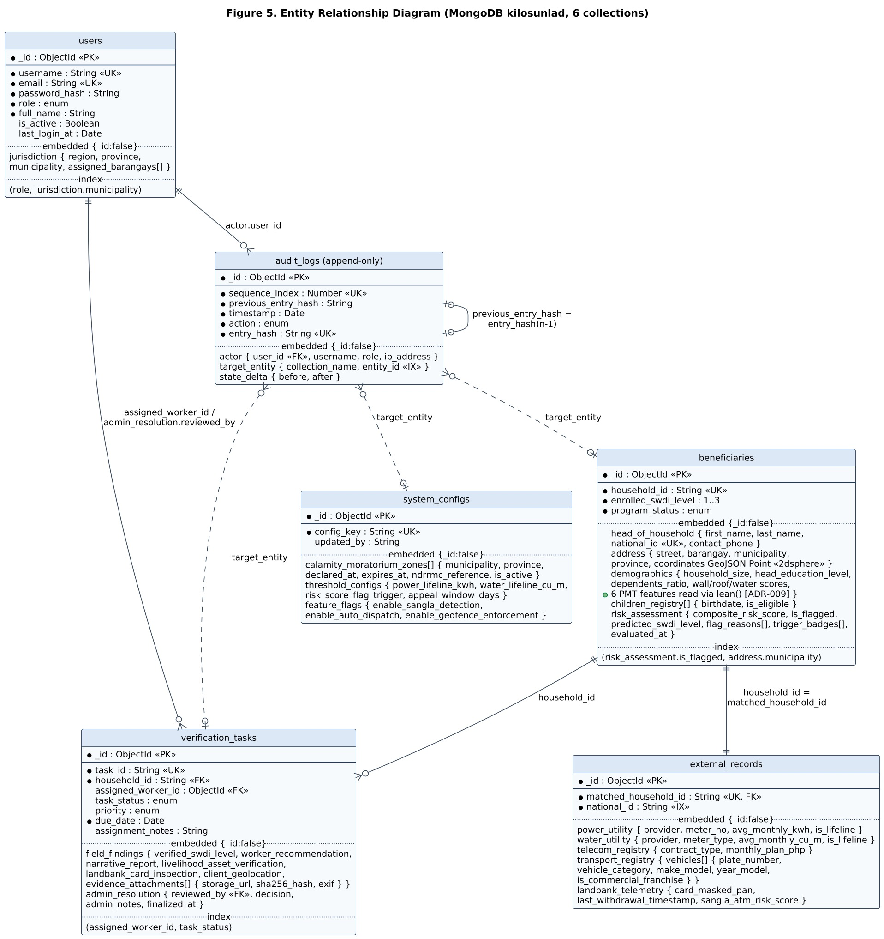
Figure 5. Entity Relationship Diagram
We used MongoDB, which stores records as documents instead of rows. The ERD shows the six collections, their main fields, their keys and indexes, and how they connect. A beneficiary (household) can have many verification tasks, each task is assigned to one user, and every change to a household, task or setting is recorded in the audit_logs collection. Each audit record also links to the previous one through its hash, which forms the chain. External records (electricity, water, phone, vehicle and ATM data) are linked to a household by its household ID.

8.2 Database Tables
Collection | Purpose
users | User accounts: username, bcrypt password hash, role (Super Admin, Regional Director, Case Worker, COA Auditor), assigned municipality and barangays, and whether the account is active.
beneficiaries | One record per household: household ID, head of household, address with GPS coordinates, the six survey features used by the model, enrolled SWDI level, program status, children, and the latest risk assessment (score, flag, reasons).
verification_tasks | Field visits: which household, which caseworker, instructions, deadline, priority, status, the submitted report with photo fingerprint and GPS, and the director's decision.
audit_logs | The audit chain: sequence number, action (for example MODEL_FLAG_RAISED, TASK_DISPATCHED, REPORT_SUBMITTED, BENEFICIARY_RETAINED), who did it, what changed, the previous hash and this record's hash. The app can only add to it.
external_records | Synthetic outside data matched to each household: electricity use, water use, phone plan, registered vehicles and LandBank ATM logs.
system_configs | System settings and calamity declarations, such as which municipality is under a calamity freeze and its NDRRMC reference.

We did not change the structure of the database during development, except for one approved addition: the BENEFICIARY_RETAINED action in the audit log, which we needed when we added the option to keep a family on the program. Queries use compound indexes, so the database never has to read every record to answer a request.

9. User Interface Design
All screenshots below were taken from the running system with real data from our database, not from mockups. We used a simple, document-like design with plain labels so that office staff and caseworkers can use it without training.

9.1 Login Page
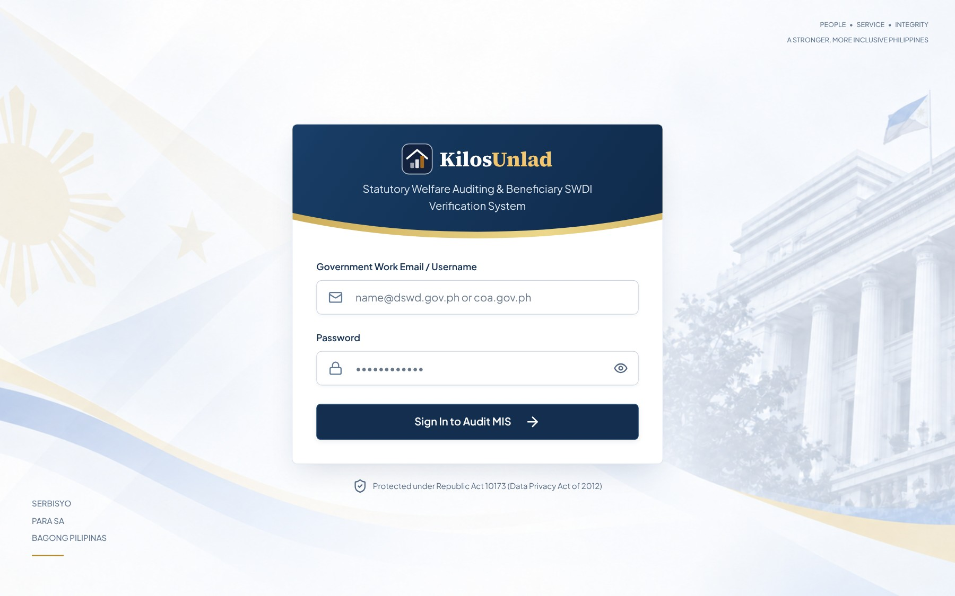
Figure 10. Login Page
Users sign in with their username and password. After signing in, each user goes straight to the screens of their own role. A wrong password shows "Incorrect username or password."

9.2 Dashboard
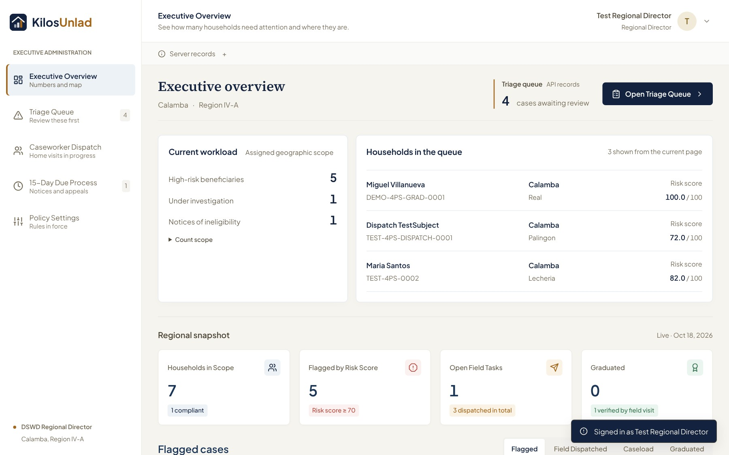
Figure 11. Executive Overview (Director Dashboard)
The Executive Overview shows the director how many households are in scope, how many were flagged, how many field visits are open, and how many families have graduated. It also has a triage summary, charts of the most common flag reasons, and a map of all households. All numbers come live from the database.

9.3 Transaction Page
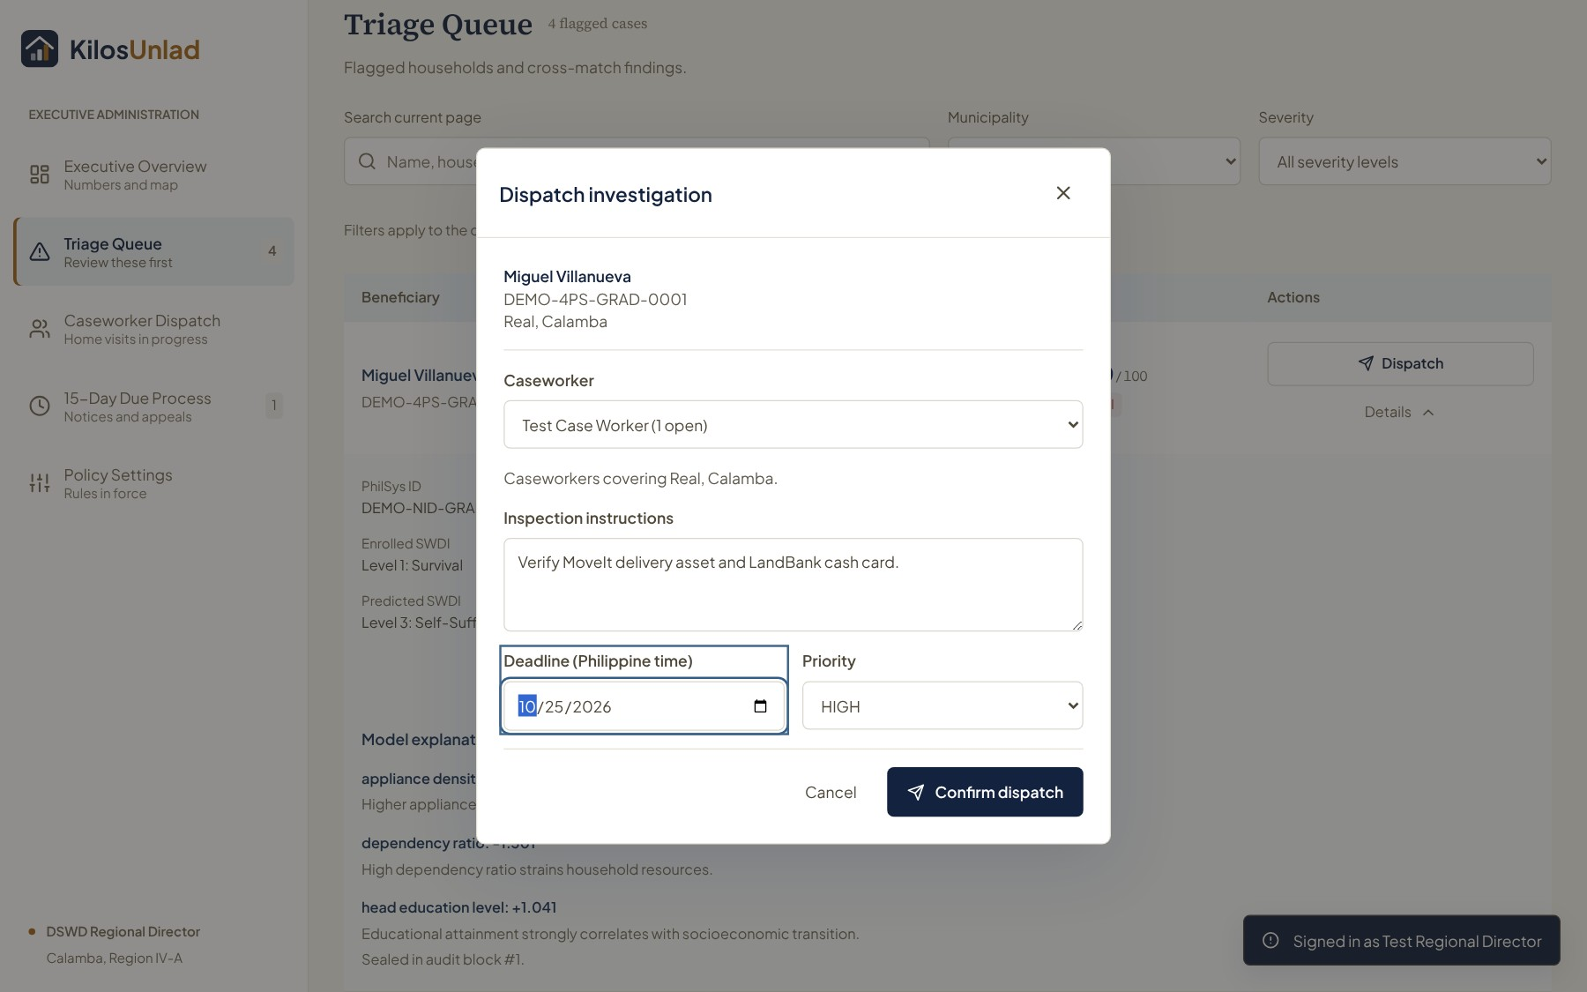
Figure 12. Dispatch Investigation Window
This is where the director sends a caseworker to a flagged household. The caseworker list shows only active caseworkers who cover that household's barangay. The director adds instructions, a deadline and a priority, then confirms.

9.4 Other Major Interfaces
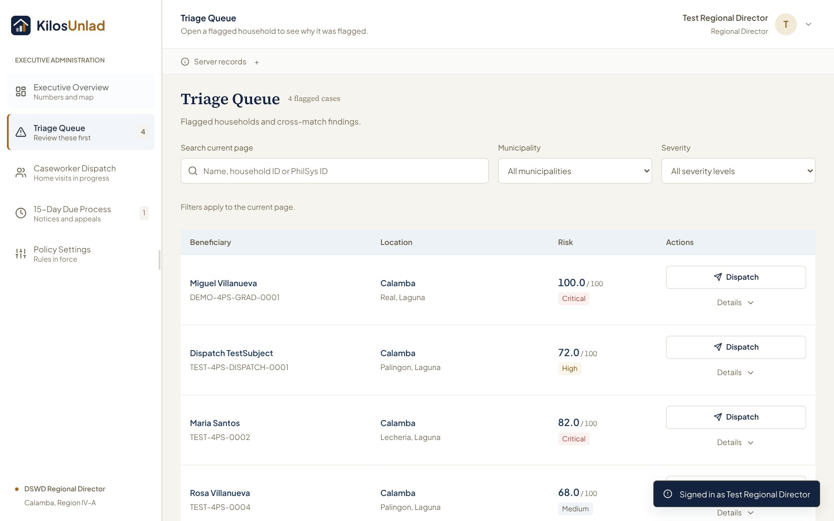
Figure 13. Triage Queue
The triage queue lists flagged households from the highest risk score down, with search and filters for municipality and severity.
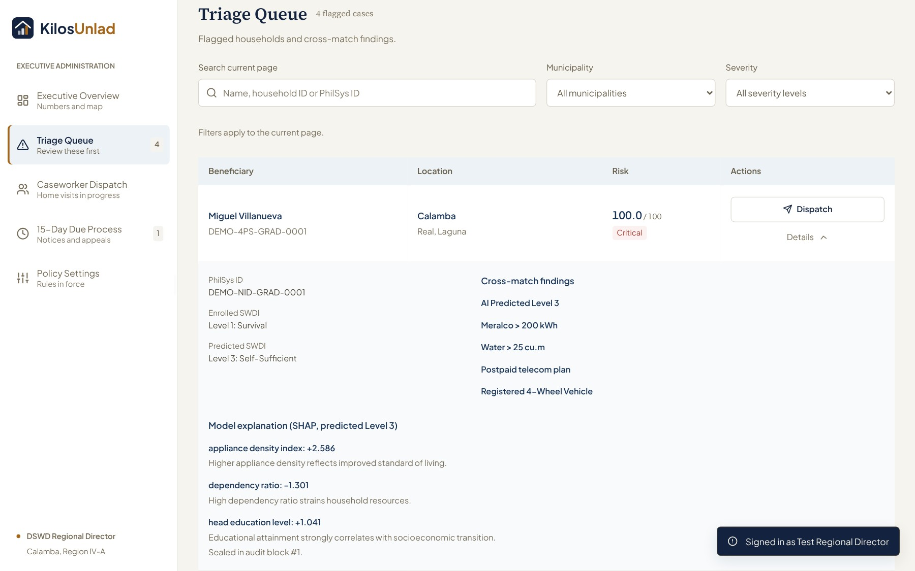
Figure 14. Household Details with the Model's Reasons
Opening a household shows why it was flagged: the trigger badges (for example "Meralco > 200 kWh") and the top three reasons from the model, together with the audit record number of the flag.
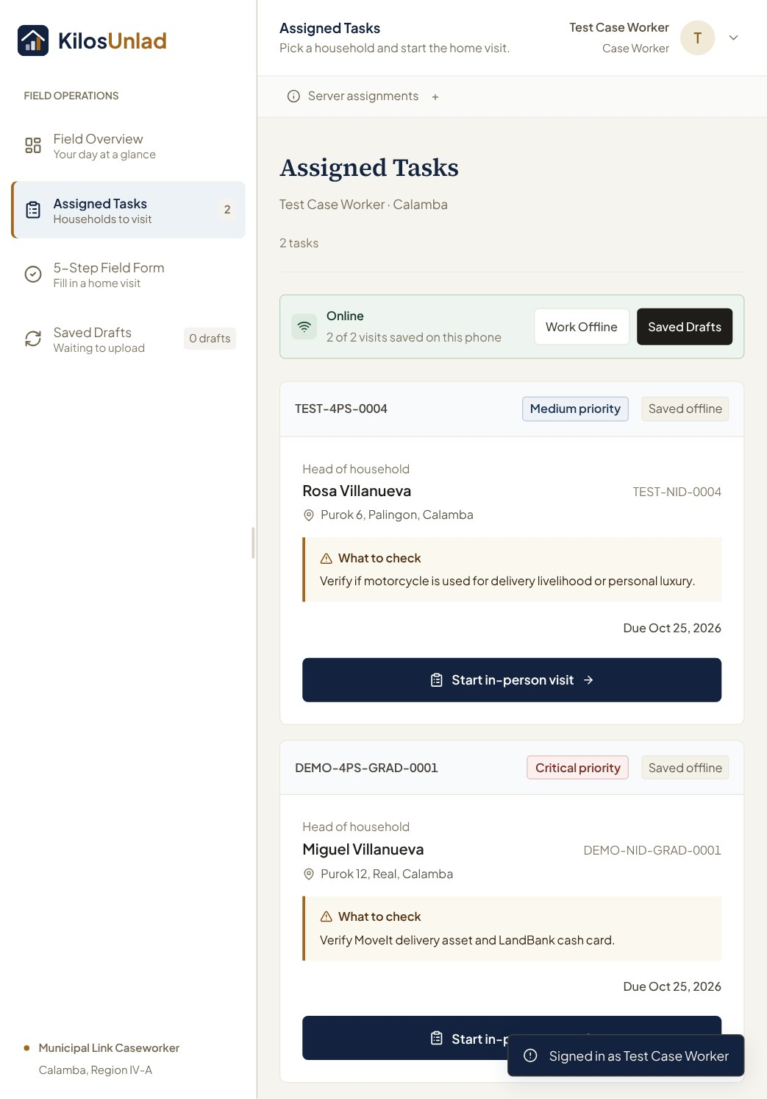
Figure 15. Caseworker's Assigned Tasks (Tablet)
The caseworker sees only their own visits, with the household, the priority, what to check, and the deadline. The banner shows if the phone is online and how many visits are saved for offline use.
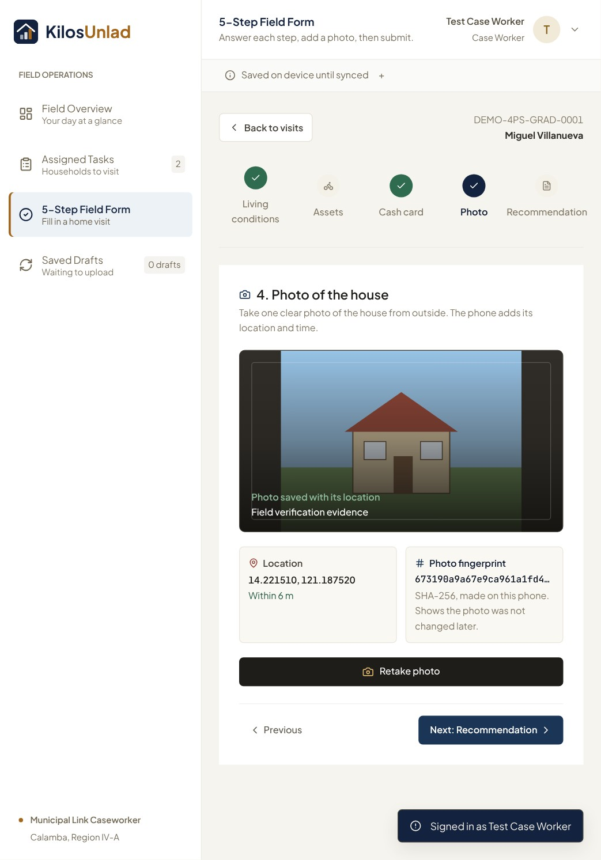
Figure 16. 5-Step Field Form, Photo Step (Tablet)
The photo step shows the photo of the house, its location and how accurate it is, and the photo fingerprint (SHA-256) made on the phone.
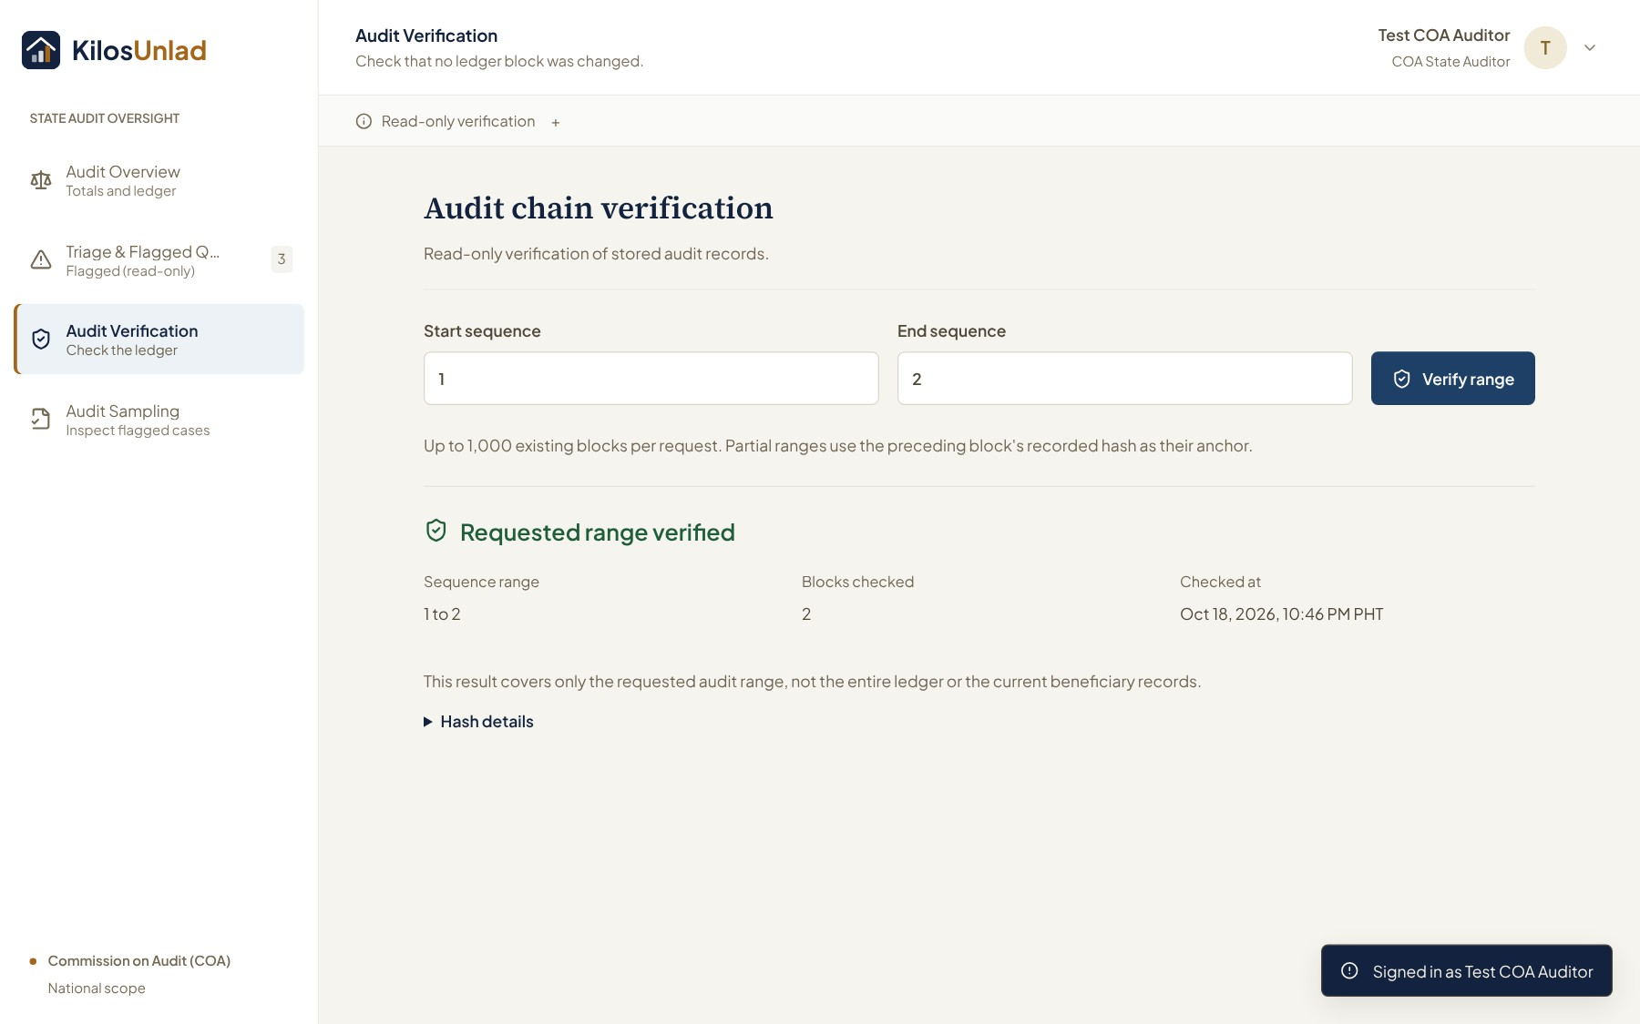
Figure 17. COA Audit Verification
The COA auditor enters a range of audit record numbers and checks it. The system recomputes every hash and says whether the chain is valid, or shows the exact record where it breaks.

10. System Implementation

10.1 Development Tools and Technologies
Tool/Technology | Purpose
TypeScript and JavaScript | Programming languages for the frontend and the backend
Python 3.10 | Programming language for the machine learning service and data scripts
React 18, Vite, Tailwind CSS | Building the screens of the web app
Dexie (IndexedDB) and a service worker | Saving reports and visits on the phone for offline use
Leaflet and OpenStreetMap | The household map on the dashboard
Node.js 20 and Express 4 | The backend API
Mongoose 8, Joi, bcryptjs, jsonwebtoken, multer, helmet | Database models, input checks, password hashing, sign-in tokens, photo uploads and security headers
MongoDB 6 (replica set) and MongoDB Atlas | The database, locally and online
FastAPI, LightGBM, SHAP, scikit-learn, pandas | The machine learning service, the model, its explanations, and model training
Docker and Docker Compose, nginx | Running all parts together on one computer, with one address
Vercel and Render | Hosting the web app (Vercel) and the API and ML service (Render)
Visual Studio Code | Code editor
Git and GitHub | Version control and teamwork through branches and pull requests
Playwright, Node test runner, pytest | Browser tests, unit tests and model tests
PlantUML | Drawing the UML diagrams

10.2 Major System Features
- Risk scoring with reasons. The model and the record checks give each household a score from 0 to 100. Every flag shows its trigger badges and top three model reasons, and is saved as an audit record.
- Triage queue and dispatch. The director sees flagged households from the highest score down and sends a caseworker who covers the barangay. The dispatch, the status change and the audit record are saved together.
- Offline field visits. Caseworkers can do the 5-step visit form with no internet. The report waits on the phone and is sent once the connection returns, with nothing lost and nothing sent twice.
- Photo proof. Each photo gets a SHA-256 fingerprint on the phone. The server checks the fingerprint and the 250-meter distance before accepting the report, and checks the photo again every time it is opened.
- Decisions and due process. The director can keep a family on the program or issue a notice. The notice opens a 15-day appeal window, and the hearing outcome is recorded before anyone graduates.
- Calamity freeze. A Super Admin can declare a calamity for a municipality, which stops dispatch and new flags there until it is lifted.
- Tamper-evident audit log. Every change is chained by hash, and the COA auditor can verify any range and see the exact record that was changed.
- Live dashboard and map. All numbers and the map are computed from the database for the user's area.
- Sangla-ATM detection. ATM log windows are checked for many cards swiped 45 seconds apart or less at one machine between 1 and 4 in the morning.
We also built a data pipeline that creates the pilot dataset. It loads 20,000 synthetic households, adds a caseworker for every barangay, and then creates real activity through the API, the same way real users would: the model scores households until about 32 are flagged, 12 are sent to caseworkers, 4 reports come back with photos, and the director issues one notice and keeps one family on the program. Because all of this goes through the API, every number on the screen is computed by the system and nothing is typed in by hand.

11. Transaction Processing
Each major transaction in KilosUnlad follows the same pattern: Input → Validation → Processing → Database Update → Confirmation/Output. Every transaction that changes data also writes one audit record in the same database transaction.

Transaction 1: Risk Assessment and Flagging
Input: The director (or the data pipeline) asks the system to assess a household by its household ID.
Validation: The user must be signed in, have the right role, and cover the household's area. The household must be Active, must not be under a calamity freeze, and must not be in the 180-day cooldown.
Processing: The API sends the six household features to the ML service, which returns the predicted SWDI level and the top three SHAP reasons. The API adds the record checks (electricity, water, phone plan, vehicle) and computes the 0 to 100 score. If the ML service does not answer within 2.5 seconds, the published rules are used instead.
Database Update: If the score is 70 or more, the household's status changes from ACTIVE_COMPLIANT to FLAGGED_FOR_REVIEW, the risk assessment is saved, and a MODEL_FLAG_RAISED audit record is added, all in one transaction.
Confirmation/Output: The household appears in the triage queue with its score, badges and reasons, and the response includes the audit record number.
Screenshot: Risk Assessment and Flagging

Transaction 2: Task Dispatch
Input: The director picks a caseworker and enters instructions, a deadline and a priority for a flagged household.
Validation: Only a director or Super Admin can dispatch. The input is checked (unknown fields are rejected). The household must be flagged, must be in the director's area, must have no open task, and must not be under a calamity freeze. The caseworker must be active and cover that barangay.
Processing: The task dispatcher creates a new task ID and prepares the status change.
Database Update: In one transaction: a new verification task is saved, the household changes to UNDER_INVESTIGATION, and a TASK_DISPATCHED audit record is added. If any part fails, nothing is saved.
Confirmation/Output: A "Task dispatched" window shows the task ID, the household and the audit sequence number. The household leaves the triage queue and appears in Caseworker Dispatch.
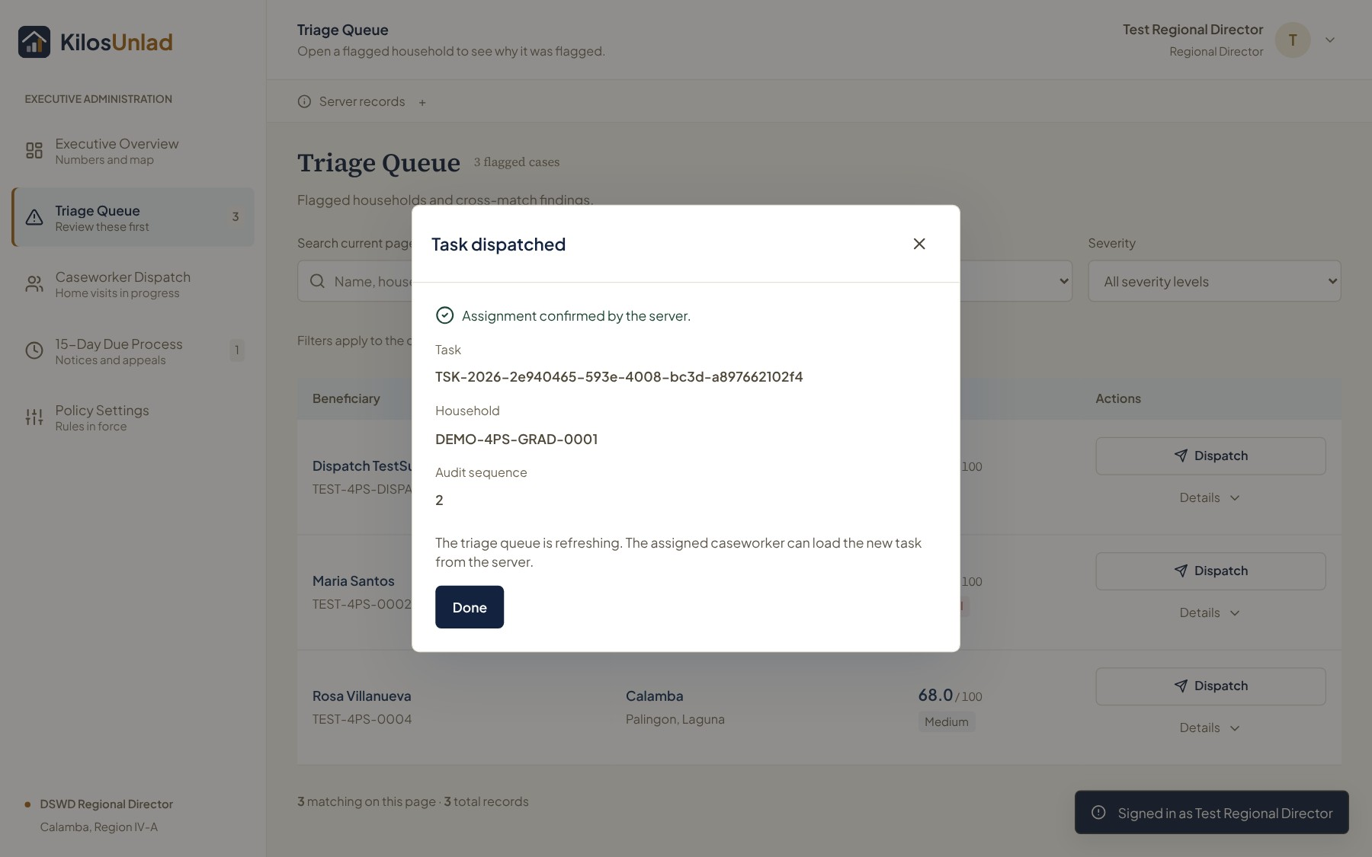
Screenshot: Task Dispatch

Transaction 3: Field Report Submission
Input: The caseworker's 5-step form, the photo, its SHA-256 fingerprint, and the GPS location.
Validation: The caseworker must own the task. The server computes the photo's fingerprint again and compares it, and checks that the location is within 250 meters of the house. A duplicate report is refused.
Processing: The photo is stored under its fingerprint, and the report is attached to the task.
Database Update: The task changes to SUBMITTED with the report, and a REPORT_SUBMITTED audit record is added in the same transaction.
Confirmation/Output: The phone marks the report as sent and the task leaves the caseworker's list. The director now sees "Review report" for that household.
Screenshot: Field Report Submission

Transaction 4: Director Decision (Keep on the Program or Issue a Notice)
Input: The director reviews the report and photo, writes the reasons (at least 10 characters), and clicks "Keep on the program" or "Approve graduation and issue notice."
Validation: The report must exist and its photo must still match its fingerprint. "Keep" is allowed only when the caseworker recommended keeping the family; "notice" is allowed only when the caseworker recommended graduation.
Processing: For "keep," the system sets the start of the 180-day cooldown. For a notice, it starts the 15-day appeal window.
Database Update: Keep: the household goes back to ACTIVE_COMPLIANT and a BENEFICIARY_RETAINED audit record is added. Notice: the household changes to NOTICE_OF_INELIGIBILITY and the decision is saved with its audit record.
Confirmation/Output: A receipt with the audit record number and either the cooldown end date or the appeal deadline.

Transaction 5: Appeal and Hearing Outcome
Input: The director files an appeal with a docket number, hearing date and reasons, and later records the hearing outcome (granted or denied).
Validation: Only one appeal per notice is allowed. The outcome can only be recorded on or after the hearing date. During a calamity, "denied" is refused but "granted" is allowed.
Processing: Filing pauses the 15-day countdown. Recording the outcome closes the appeal.
Database Update: Granted: the household returns to ACTIVE_COMPLIANT with a BENEFICIARY_RETAINED record. Denied: the household becomes GRADUATED with a BENEFICIARY_GRADUATED record.
Confirmation/Output: A message such as "Appeal … granted: the family stays on the program," with the audit record number.

12. Software Testing

12.1 Test Plan
We tested KilosUnlad at four levels. First, unit tests check single functions and routes: 69 tests for the frontend and 175 for the backend, run on a real MongoDB replica set. Second, integration test scripts check each feature through the real API, from the request down to the database and the audit chain. Third, the full Section 12 test plan runs all the main test cases (TC-01 to TC-24) in order on the Docker version of the system, resetting the data between steps. Fourth, browser tests open the real app in Chrome at phone, tablet and desktop width and click through every role.
We also prepared 33 manual tests grouped by role (Director, Caseworker, COA Auditor, Super Admin and cross-role) that anyone can follow on the 20,000-household dataset. Every test ID, script and result is listed in our test catalog (docs/testing/MASTER_TEST_CATALOG.md). The final runs were done on the final build after the last merge.

12.2 Test Cases and Results
Test Case ID | Feature/Transaction | Expected Result | Actual Result | Status
TC-01 | Sign-in and role access | Each role signs in and sees only its own screens; a wrong role gets 403. | All four roles signed in to their own screens; wrong-role and out-of-area requests returned 403. | Pass
TC-02 | Wrong password and expired token | Wrong password is refused; an expired or fake token returns 401. | Wrong password refused with "Incorrect username or password"; expired token returned 401. | Pass
TC-03 | SWDI prediction with reasons | The model returns a level and the top 3 SHAP reasons. | Predicted level and three SHAP reasons returned and shown in the details drawer. | Pass
TC-04 | Risk scoring and flagging | Case A scores 100 and is flagged with its reasons and an audit record. | Case A scored 100, was flagged, and a MODEL_FLAG_RAISED block was added. | Pass
TC-05 | Task dispatch transaction | Task, status change and audit record are saved together. | Task created, household moved to Under Investigation, audit sequence returned; chain valid. | Pass
TC-06 | Duplicate dispatch prevention | A second dispatch for the same household is refused, even when sent at the same time. | Second dispatch refused (409); concurrent requests created exactly one task. | Pass
TC-07 | Offline task caching | Assigned visits stay available with no internet. | Visits opened and the form completed in the browser with the network offline. | Pass
TC-08 | Geofence (250 m) | A report taken more than 250 m from the house is refused. | Report from outside the geofence refused (422); report at the house accepted. | Pass
TC-09 | Photo fingerprint check | A photo whose bytes were changed is refused. | Altered photo refused (422); original photo accepted. | Pass
TC-10 | Offline sync on reconnect | Saved reports are sent once when the connection returns. | Pending report sent after reconnecting; one REPORT_SUBMITTED block, no duplicate. | Pass
TC-11 | Notice and 15-day window | A notice opens a 15-day appeal window with grants continuing. | Notice issued with a 15-day countdown; early graduation refused (APPEAL_WINDOW_OPEN). | Pass
TC-12 | Filing an appeal | An appeal is filed once; a second appeal is refused. | Appeal docketed and countdown paused; second appeal refused. | Pass
TC-13 | Audit chain verification | Verifying the ledger reports it as valid. | Every range verified as valid. | Pass
TC-14 | Tamper detection | Editing an audit record directly in the database is detected at that record. | Edited block 3 detected (INVALID_HASH_AT_SEQUENCE_3); other ranges still valid. | Pass
TC-15 | Sangla-ATM detection | A syndicate ATM window scores high and flags the linked households. | Window scored 85.0 out of 100 and the linked households were flagged. | Pass
TC-16 | Calamity freeze | During a calamity, dispatch and flags are refused; they work again after it is lifted. | Dispatch and assessment refused while active; allowed again after lifting; director could not declare. | Pass
TC-17 | Indexes at 80,000 records | Queries use an index, never a full scan. | Index scan (IXSCAN) used; no collection scan. | Pass
TC-18 | Live dashboard and map | Dashboard numbers and map come from the database, with no sample data. | All counts matched the database for each role; no sample labels. | Pass
TC-19 | Phone, tablet and desktop layout | No sideways scrolling at 390, 834 and 1440 px for any role. | Every screen of every role passed at all three widths. | Pass
TC-20 | Report review and photo integrity | The director sees the report and a verified photo; a changed photo file is refused. | Photo shown as "Hash verified"; altered file refused (409). | Pass
TC-21 | Graduation only after the window | Graduation is refused during the window and allowed after it. | Refused during the window; completed after it with a BENEFICIARY_GRADUATED block. | Pass
TC-22 | Keep a family on the program | A "retain" report lets the director keep the family; the household returns to Active. | Household returned to Active with a BENEFICIARY_RETAINED block. | Pass
TC-23 | Appeal hearing outcome | Granted keeps the family; denied graduates it; each is recorded once. | Granted returned the family to Active; denied graduated it; a second outcome was refused. | Pass
TC-24 | 180-day re-flag cooldown | A kept family cannot be flagged again for 180 days. | Re-assessment refused with RETENTION_COOLDOWN. | Pass
TC-25 | Deployment dataset (20,000 households) | 20,001 households, 25 to 40 model flags, a caseworker for every barangay, every task in the right barangay, valid ledger. | 20,001 households; 32 flags all from the model; every barangay covered; every task in its barangay; ledger valid. | Pass
TC-26 | Full process on the Docker stack | Flag, dispatch, report and audit work end to end through the gateway. | The whole chain completed through the gateway and the ledger verified. | Pass
Results from the final runs on the final build (Section 12 plan, full rehearsal and deployment dataset check): 26 of 26 test cases passed. Logs are in docs/testing/evidence/final-2026-10-18.

12.3 Defects and Corrective Actions
Defect | Corrective Action | Status
Saving a change and its audit record together failed on a single MongoDB server (transactions need a replica set). | Ran MongoDB as a replica set and set it up automatically when the containers start. | Resolved
Checking the audit log's indexes returned "Unauthorized" for the app account. | Gave the app account permission to list and create indexes on the audit log only, still without edit or delete rights. | Resolved
MongoDB added unwanted IDs to small nested records. | Turned off automatic IDs for nested records in the models. | Resolved
The database port clashed with another MongoDB already running on the computer. | Made the outside port configurable, with 27017 as the default. | Resolved
The API and the ML service did not agree on the household features, so the model rejected requests (422). | Matched the backend input check to the six features the model expects. | Resolved
Dispatch details (priority, deadline, notes) were thrown away. | Saved these details in the task and recorded them in the audit log. | Resolved
The 80,000-household data could not be loaded and was invisible to area-limited queries. | Fixed the loader so every record matches the models and has its municipality and barangay. | Resolved
Offline sync could not work: saved drafts did not match the API and photos had nowhere to be stored. | Rebuilt the draft format to match the API, added the verified SWDI level, and added photo storage. | Resolved
Report submission skipped the geofence and the photo check, and saved nothing. | Added the 250-meter geofence, the fingerprint check, and saving of the report with its audit record. | Resolved
Dispatch still went through during a declared calamity. | Added the calamity check inside the dispatch transaction. | Resolved
Starting the containers also ran the reset job, which would wipe a running database. | Moved the one-time jobs to a separate "tools" profile so they only run when called. | Resolved
A director could not keep a family that the caseworker found was still poor, and appeals had no ending. | Added "Keep on the program," recording of the hearing outcome, and the 180-day cooldown (DECISION-012). | Resolved
Our QA testers saw old screens and 404 errors. | The cause was old Docker images. We added a build check (it must print 401) and clearer rebuild steps. | Resolved
On Windows Git Bash, paths and "!" in passwords broke some commands. | Added two setup lines (MSYS_NO_PATHCONV and set +H) to the guides and scripts. | Resolved
On a laptop, the photo step timed out waiting for GPS. | Explained the browser location override in the guide; phones outdoors work normally. | Resolved
The caseworker screens fell back to the Courier font and used hard words. | Bundled the fonts and rewrote the labels in plain words. | Resolved
A stray space in the demo loader's file path made it always take the slow path. | Fixed the path during the final merge. | Resolved

12.4 User Acceptance Testing (UAT)
We prepared a UAT form for four tasks: (A) triage and dispatch by the director, (B) an offline field visit by a caseworker, (C) reviewing a report, issuing a notice and filing an appeal, and (D) verifying the audit log as the COA auditor. Each participant also answers the 10-item System Usability Scale (Brooke, 1996). We set our pass rule before testing: an average SUS score of 68 or higher, and each task completed by at least 80% of the participants who tried it.
The system was presented and demonstrated to our adviser, Mr. Rogel M. Labanan, and to the panel, where we ran these same flows live on the system. Our adviser approved the system. We did not run formal SUS sessions with DSWD staff, so we do not report a SUS score here. We did not want to make up ratings. The form and the scoring script are ready in our repository (docs/testing/uat) for when the system is tested with real users.
UAT Task | Who | Result
A. Triage and dispatch | Regional Director | Demonstrated live and approved by the adviser
B. Offline field visit | Caseworker | Demonstrated live and approved by the adviser
C. Report review, notice and appeal | Regional Director | Demonstrated live and approved by the adviser
D. Audit log verification | COA Auditor | Demonstrated live and approved by the adviser
System Usability Scale (SUS) | DSWD staff (planned) | Not yet conducted

13. Challenges and Solutions
Challenge | Solution
We could not use real government or bank data because of the Data Privacy Act and the Bank Secrecy Law. | We built a data generator that makes realistic synthetic households, with groups such as "graduated but not reported" and "still poor," plus controlled noise so the data is not too clean.
Our first model scored well on synthetic data but much lower on real survey data. | We trained on 29,080 real households from the PSA survey, compared five training setups on households the model never saw, and chose the best one (macro F1 0.6244). We made sure a flag only schedules a visit, so a wrong prediction cannot hurt a family.
Caseworkers often have no signal in the barangay. | We made the app save reports on the phone and send them automatically later, and we tested it with the network cut and with the server stopped.
We had to make sure records could not be changed quietly. | We chained every audit record with SHA-256 and gave the app's database account add-only rights on the audit log.
Some changes touch three records at once (task, household, audit). If one failed, the data would not match. | We used database transactions so that all three are saved together or not at all.
The first version had no way to keep a family that was still poor, and appeals had no ending. | We added "Keep on the program," the hearing outcome, and a 180-day cooldown, with only one approved change to the database.
Five members worked on separate parts that had to fit together. | We wrote fixed API contracts (docs/contracts), used branches and pull requests, and wrote a test script for every connection before merging.
Free hosting plans sleep and have small limits. | We documented the limits, kept the dataset small (20,000 households, about 2 MB compressed), and wrote a guide for waking the services before a demo.
Teammates on Windows had trouble running the scripts. | We added Git Bash fixes to the scripts and wrote step-by-step guides with a troubleshooting table.

14. Conclusion
We were able to build KilosUnlad and meet our objectives. The scoring engine combines a LightGBM model with simple record checks and explains every flag. Caseworkers can do field visits offline with photos that are checked by fingerprint and location. Every change is saved in a hash-chained audit log that the COA auditor can verify. Families get a 15-day appeal window, and every appeal ends with a recorded outcome. Sangla-ATM patterns can be detected from ATM logs. The system is tested and hosted online, and our adviser approved it.
Our biggest accomplishment is that the whole process works from start to finish without dead ends: flag, dispatch, field report, then either keeping the family on the program or a notice, an appeal window, and graduation or a recorded hearing outcome. On our 20,000-household pilot dataset, the system narrowed the list down to 32 households worth visiting, about one in every 625, and no family was removed without a person deciding.
In terms of performance, all 69 frontend tests and 175 backend tests pass, the full Section 12 test plan and the full rehearsal of every integration script pass on the final build, and the screens work on phones, tablets and desktops. The model's macro F1 of 0.6244 is below our target of 0.85, which we accept for now because a person always checks the household in the field.
There are still things to improve. The model can be made better, especially for Level 1 households, by mixing in synthetic data (which already raised Level 1 F1 from 0.382 to 0.443 in one of our tests) and by retraining on real field results. The system should connect to real data sources once data-sharing agreements are in place, lock accounts after many wrong passwords, support ordering a second field visit, use paid hosting that keeps photos, and run real UAT sessions with DSWD staff. With these changes, KilosUnlad could help the 4Ps reach more of the families who really need it.

15. References
Brooke, J. (1996). SUS: A "quick and dirty" usability scale. In P. W. Jordan, B. Thomas, B. A. Weerdmeester, & I. L. McClelland (Eds.), Usability evaluation in industry (pp. 189–194). Taylor & Francis.
Department of Social Welfare and Development. (2023). Approved guidance note on the integration of community organizing in the Kilos-Unlad strategy of 4Ps. Pantawid Pamilyang Pilipino Program. https://pantawid.dswd.gov.ph/wp-content/uploads/2023/03/APPROVED-GUIDANCE-NOTE-ON-THE-INTEGRATION-OF-COMMUNITY-ORGANIZING-IN-THE-KILOS-UNLAD-STRATEGY-OF-4PS.pdf
Ke, G., Meng, Q., Finley, T., Wang, T., Chen, W., Ma, W., Ye, Q., & Liu, T.-Y. (2017). LightGBM: A highly efficient gradient boosting decision tree. In Advances in Neural Information Processing Systems 30 (pp. 3146–3154). Curran Associates.
Lundberg, S. M., & Lee, S.-I. (2017). A unified approach to interpreting model predictions. In Advances in Neural Information Processing Systems 30 (pp. 4765–4774). Curran Associates.
National Institute of Standards and Technology. (2015). Secure hash standard (SHS) (FIPS PUB 180-4). U.S. Department of Commerce. https://doi.org/10.6028/NIST.FIPS.180-4
Philippine Statistics Authority. (2016, October 24). Average family income in 2015 is estimated at 22 thousand pesos monthly (Results from the 2015 Family Income and Expenditure Survey). https://psa.gov.ph/content/average-family-income-2015-estimated-22-thousand-pesos-monthly-results-2015-family-income
Republic Act No. 10121. (2010, May 27). An act strengthening the Philippine disaster risk reduction and management system, providing for the national disaster risk reduction and management framework. Official Gazette of the Republic of the Philippines. https://www.officialgazette.gov.ph/2010/05/27/republic-act-no-10121/
Republic Act No. 10173. (2012, August 15). Data Privacy Act of 2012. National Privacy Commission. https://privacy.gov.ph/data-privacy-act/
Republic Act No. 11310. (2019, April 17). An act institutionalizing the Pantawid Pamilyang Pilipino Program (4Ps). Official Gazette of the Republic of the Philippines. https://www.officialgazette.gov.ph/2019/04/17/republic-act-no-11310/
Republic Act No. 11552. (2021, May 27). An act extending and enhancing the implementation of the lifeline rate, amending for the purpose Section 73 of Republic Act No. 9136, otherwise known as the "Electric Power Industry Reform Act of 2001". Official Gazette of the Republic of the Philippines. https://www.officialgazette.gov.ph/2021/06/07/republic-act-no-11552/
Republic Act No. 1405. (1955, September 9). An act prohibiting disclosure of or inquiry into, deposits with any banking institution and providing penalty therefor. The LawPhil Project. https://www.lawphil.net/statutes/repacts/ra1955/ra_1405_1955.html
Republic Act No. 9510. (2008, October 31). An act establishing the Credit Information System, and for other purposes. Credit Information Corporation. https://cic.gov.ph/republic-act-no-9510-credit-information-system-act-cisa/

16. Appendices

Appendix A – Requirements Gathering Evidence
Our requirements came from the documents listed in Section 15. The table below shows which document each main requirement came from.
Source | What we took from it
Republic Act No. 11310 (4Ps Act) | Who qualifies, the seven-year limit, due process before a family leaves the program (FR-12 to FR-14, business rules 1, 6)
DSWD Kilos-Unlad guidance note | How caseworkers work with families; the idea of moving from survival to self-sufficiency (SWDI levels)
PSA 2015 FIES | The household features used by the model and the real data used to train it (FR-03)
Republic Act No. 11552 (Lifeline Rate) | The 200 kWh electricity limit used in the risk score (business rule 2)
Republic Act No. 10121 (DRRM Act) | The calamity freeze (FR-15, business rule 8)
Republic Act No. 10173 (Data Privacy Act) | Using synthetic data and collecting only what is needed (limitations, NFR privacy)
Republic Act No. 1405 and No. 9510 | Not using bank deposit or credit data; only ATM log patterns for Sangla-ATM (FR-17)

Appendix B – Additional UML Diagrams
All UML diagrams are included in Sections 6, 7 and 8 (Figures 1 to 9). Their editable PlantUML sources are in docs/diagrams/src of the repository, and docs/diagrams/src/build_all.sh redraws all of them.

Appendix C – Additional Screenshots
More screenshots for every role at phone, tablet and desktop width are in docs/diagrams/ui and docs/testing/evidence of the repository.

Appendix D – Testing Evidence
The charts below show how the final model (version 2) did on 6,232 real households it never saw during training.
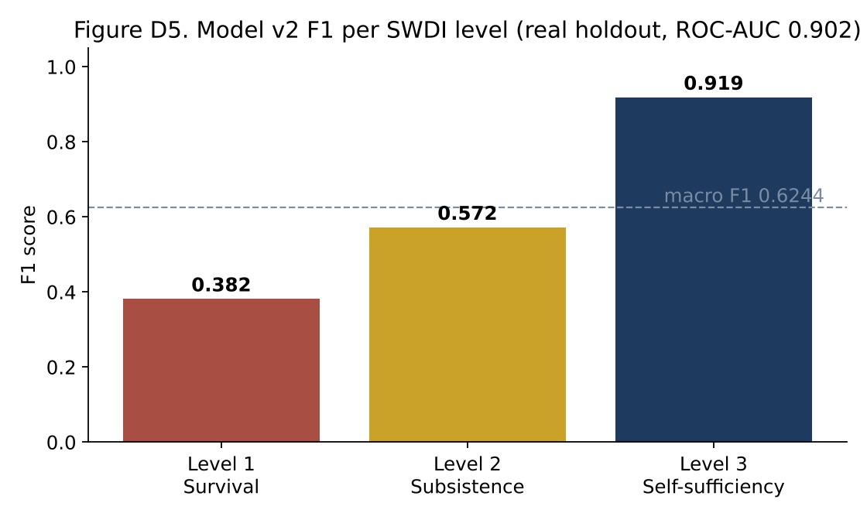
Figure D1. Model v2 F1 Score per SWDI Level
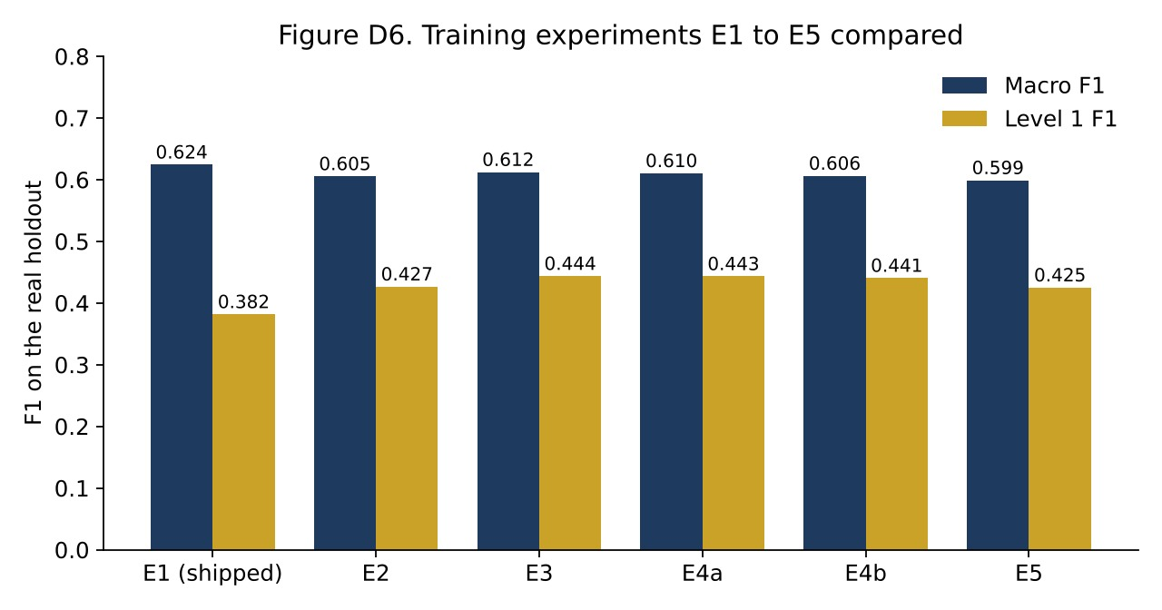
Figure D2. The Five Training Experiments Compared
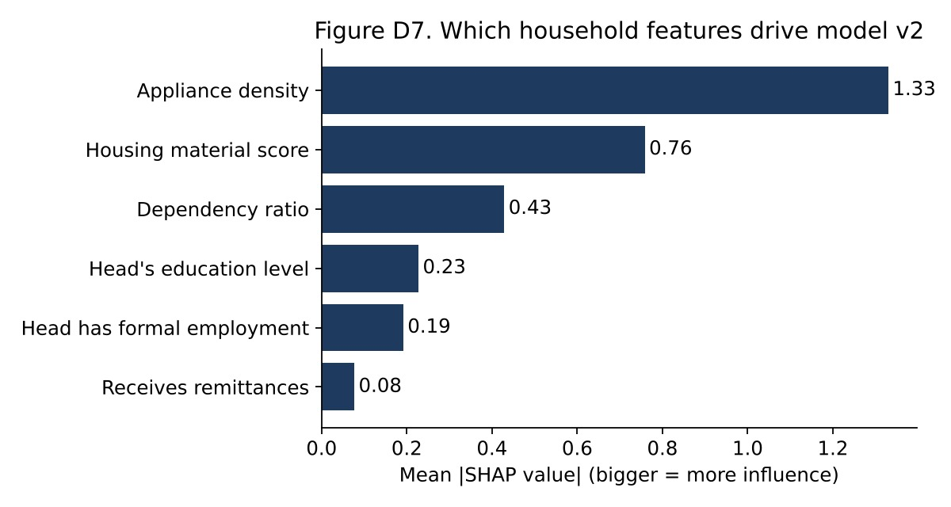
Figure D3. Which Household Features Drive the Model (SHAP)
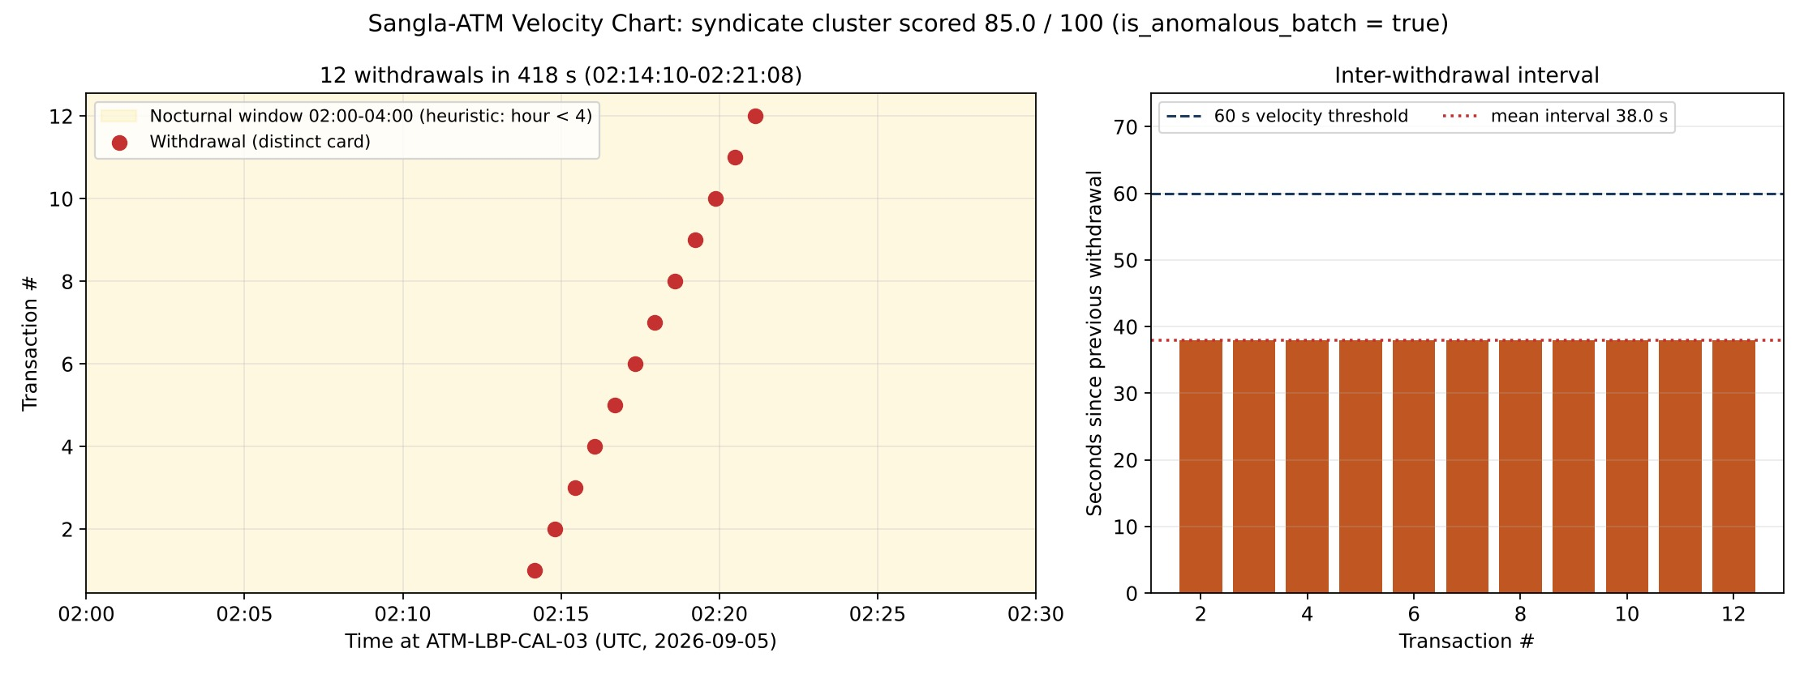
Figure D4. Sangla-ATM Detection on a Demo ATM Log Window
The full logs of the final test runs (Section 12 plan and the full rehearsal), the unit test reports, and the browser screenshots are in docs/testing/evidence and docs/integration/evidence of the repository.

Appendix E – UAT Results
The UAT form (docs/testing/uat/UAT_RATING_FORM.md) and the scoring script (data-pipeline/scripts/score_uat.py) are ready. As explained in Section 12.4, the system was demonstrated to and approved by our adviser, and formal SUS sessions with DSWD staff have not been conducted yet.

Appendix F – Source Code / Repository Information
Item | Details
Repository | https://github.com/renzv-compsci/KilosUnlad
Live system | https://kilos-unlad-33qx7w3d9-yuidevs.vercel.app/
How to run locally | README.md, section "If the live site is not working: run it on your own computer" (7 steps, including loading the data)
Test accounts | director_test, case_worker_test, cw_palingon_1, cw_palingon_2, cw_lecheria, cw_real, auditor_test, super_admin_test (passwords in README.md)
Main folders | client (web app), server (API), ml-service (model), data-pipeline (data and test scripts), docs (diagrams, contracts, decisions, tests), deploy (hosting)
License | MIT

Appendix G – Individual Contributions
See the Individual Contribution table on the next page.
INDIVIDUAL CONTRIBUTION
Member | Assigned Responsibilities | Actual Contribution
Viloria, Renz Jerik C. | Project Manager / Data Engineering Lead: plan and schedule, integration of all parts, data pipeline and seeding | Led the sprints and merges; built the synthetic data generator, the 20,000-household deployment dataset and the seeding scripts; wrote the integration test scripts and the test plan runner; set up hosting on Vercel, Render and Atlas; prepared the documentation.
Cabatian, Charles John R. | Machine Learning Lead: model, explanations, Sangla-ATM detection | Prepared the PSA FIES features; trained and compared the five model experiments; shipped LightGBM v2 with SHAP explanations; built the FastAPI ML service and the Sangla-ATM detector; made the model evaluation charts.
Mojica, Markie Angelo S. | Frontend Development: screens, offline app, usability | Built the React screens for all four roles; the offline-first PWA with IndexedDB and automatic sync; the photo fingerprint and GPS step; the dashboard map; the final plain-language restyle and the phone, tablet and desktop layouts.
Martinez, Kit Dustin P. | Database Lead: data models, indexes, audit chain | Designed the six MongoDB collections and their indexes; set up the replica set and the append-only database role for the audit log; made the ERD; checked index use and data integrity at 80,000 records.
Santos, Ma. Mae S. | Backend Infrastructure Lead: API, security, workflow | Built the Express API and its 23 routes; the six guards (sign-in, role, area, input, rules, seal); the workflow and transactions for dispatch, reports, notices, retention and appeals; the API contracts; and the backend unit tests.

